Instruction manual

R410/R410SS
F410/F410SS

DLW Ver1.2
Dear Customer,
Congratulations on your purchase of this product. Like all our products , this product has also been developed on the basis of the latest technology and produced using reliable and modern electrical components.
Please take a few minutes before starting operation of the appliance and read the following operating instructions. Save this manual for further reference.

Safety Tips
1. The appliance is intended for commercial use or similar use (etc. to be used by a layman in shops).
2. DO NOT use the appliance outside.
3. DO NOT attempt to service the item yourself.
4. DO NOT use damaged appliances. If you are in any doubt, consult service agent.
5. DO NOT use electrical appliances inside the appliance (e.g. heaters, ice-cream makers etc.), unless they are of the type recommended by the manufacturer.
6. Keep ventilation openings, in the appliance enclosure or in the built-in structure, clear of obstruction.
7. DO NOT use mechanical devices or other means to accelerate the defrosting process, other than those recommended by the manufacturer.
8. DO NOT damage the refrigerant circuit.
9. DO NOT stand or support yourself on the base, drawers or the door.
10. DO NOT allow oil or fat to come into contact with the plastic components or door seal. Clean immediately if contact occurs.
11. DO NOT place combustible, explosive or volatile articles, corrosive acids or alkalis or liquids in the appliance.
12. DO NOT use this appliance to store medical supplies.
13. DO NOT use jet/pressure washers to clean the appliance.
14. DO NOT allow children to play with the packaging, and destroy plastic bags safely.
15. Bottles that contain a high percentage of alcohol must be sealed and placed vertically in the refrigerator.
16. Always carry, store and handle the appliance in a vertical orientation and move by holding the base of the appliance.
17. Always switch off and disconnect the power supply to the unit before cleaning.
18. If the supply cord is damaged, it must be replaced by the manufacturer, its service agent or similarly qualified persons in order to avoid a hazard.
19. This appliance is not intended for use by persons (including children) with reduced physical, sensory or mental capabilities, or lack of experience and knowledge, unless they have been given supervision or instruction concerning use of the appliance by a person responsible for their safety.
20. Children should be supervised to ensure that they do not play with the appliance.
21. For indoor used only. Not suitable for installation in an area where a water jet could be used.Must not be cleaned by a water jet.
22. To guarantee safe operation, ensure that the appliance is set up and connected as described in the instruction manual.
23. Any repairs and work on the appliance should only be carried out by the customer service department.
24. Maximum loading of each shelf is 25 kg.
25. The key to the fridge/freezer should be kept out of the reach of children and users.
Intended Use
Only use this appliance for cooling and storage of food and beverage for commercial purposes.
Location and Installation
The cabinet should be placed in a room that is dry and sufficiently ventilated. To operate efficiently it should not be positioned in direct sunlight or near warm appliances. Please note that optimal cabinet performance is obtained at an ambient temperature between +16℃ and +35℃.

Refrigerator: By placing the cabinet in an environment with high air humidity, it may be necessary to acquire extra equipment for evaporation of the drip water in the pan near the compressor.
The cabinet can be installed freestanding against a wall.
Important
The cabinet must have sufficient ventilation and free air circulation beneath, above and behind the cabinet. The legs under the cabinet will help ensure sufficient air space.
• Remove the appliance from the packaging. Make sure that all protective plastic film and coatings are thoroughly removed from all surfaces. To prevent injury or damage to the unit, we recommend that the appliance should be unpacked and set up by two people.
• The appliance should be placed on a solid level floor to reduce noise and vibration. Level the appliance by adjusting the screw feet.
• Check that the power supply and voltage used comply with the details on the rating plate. The plug must be accessible after installation.
• Correctly connect and disconnect the plug. When inserting ensure the plug is fully engaged. When unplugging do so by holding the body of the plug. Never pull the supply cord directly.
• If the appliance is to be shut down for long period, switch it off and disconnect the plug from socket outlet. Clean the appliance and leave the door open to prevent odour.
• Important! For your personal safety, this appliance must be properly grounded (earthed). This appliance is equipped with a cord having a grounding wire with a grounding plug. The plug must be insert ed into an outlet that is properly grounded and installed. Consult a qualified electrician or service center if you do not completely understand the grounding instructions. If doubt exists whether the appliance is properly grounded, have a qualified electrician check the circuit to make sure the outlet is properly grounded.
• If the cable does not reach the nearest socket, either rearrange your store layout or ask a qualified electrician to fix a new socket.
• If power is cut off, wait for at least 3 minutes before restarting the appliance to avoid damaging the compressor.
Note: If the unit has not been stored or moved in an upright position, let it stand upright for approximately 12 hours before operation.
Note: Before using the appliance for the first time, clean the shelves and interior with water.
Power Requirements
The cabinet is intended for connection to an alternating current. The connection voltage (V) and frequency (Hz) are shown on the nameplate in the cabinet. The power connection is made using a three-pin plug to a wall socket. Any requirement for earthing from the local power supply must be met. The cabinet plug and wall socket should then give a correct earthing.
If you are in doubt,contact your local supplier or authorized electrician.
Warning - This appliance must be earthed
The flexible cord fitted to this appliance has three cores for use with a 3-pin 13Amp plug. If a B.B. 1363 (13 Amp)fused plug is used, it should be fitted with a 13 Amp fuse or a moulded right- angled Schuko plug. Note the plate with a hole in it between and above the two pins - this connects to French and Belgian sockets, which have an earth pin that sticks out. Running in a slot coming from that plate is a continuation strip from the plate. Other European countries use a socket with a scrolled metal connector emerging from the side which mates with that strip. This ensures that the Schuko can be used in most mainland European countries.
Important
The wires in this mains lead are coloured in accordance with the following code:
Green-and-yellow: earth
Blue: neutral
Brown: live
The colours of the wires in the mains lead of this appliance might not correspond with the coloured markings identifying the terminals in your plug. Proceed as follows:
The wire which is coloured green-and-yellow must be connected to the terminal in the plug which is marked “E”, marked by the earth symbol or coloured green-and-yellow. The wire, which is coloured blue, must be connected to the terminal, which is marked with the letter “N”, or coloured black. the wire which is coloured brown must be connected to the terminal which is marked with the letter “L” or coloured red.

Starting Up
Plug in the cabinet.
The display shows the actual cabinet temperature
Servicing
Make sure the appliance is switched off at the mains
before service is performed on electrical parts.

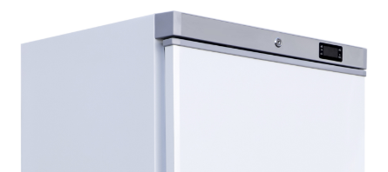
Thermostat Display

Lock

Operation
Storing food
To get the best results from your appliance, follow these instructions:
• Only store foodstuffs in the appliance when it has reached the correct operating temperature.
• Always close the door, when not in use and appliance is switched on.
• Do not place uncovered hot food or liquid inside the appliance.
• Wrap or cover food where possible.
• Do not obstruct the fans inside the appliance. (Refrigerator)
• Avoid opening the door for prolonged periods of time.
• The maximum load for a shelf is 25 kg.
• The food must be put into container before placed into cabinet or on the shelf. Food must not be placed into food cabinet directly.
Turn on
• Close the door of the appliance.
Temperature setting and control
Please check attached interleaf for thermostat parameter adjustment operating instruction.

Defrosting Procedure
Refrigerator:
Automatic Defrosting using automatic water evaporation.
Automatic defrost : The appliance will automatically run defrost cycles
Note: The cycle starts from the time the appliance is initially powered up.
To manually defrost the appliance:
• Press and hold the DEFROST button for 5 seconds.
• The defrost cycle will start immediately and the Defrost LED illuminates.
Note: Starting a manual defrost also resets the automatic defrost timer. The next automatic defrost will start according to the set parameter after the manual defrost has finished.
Never use a sharp or pointed object that may damage the refrigerator.

Changing the Door Hinge
The door can be changed from right hand-hinged to left hand-hinged, or vice versa.
To do so, proceed as follows:
- Switch off power and disconnect from the main socket
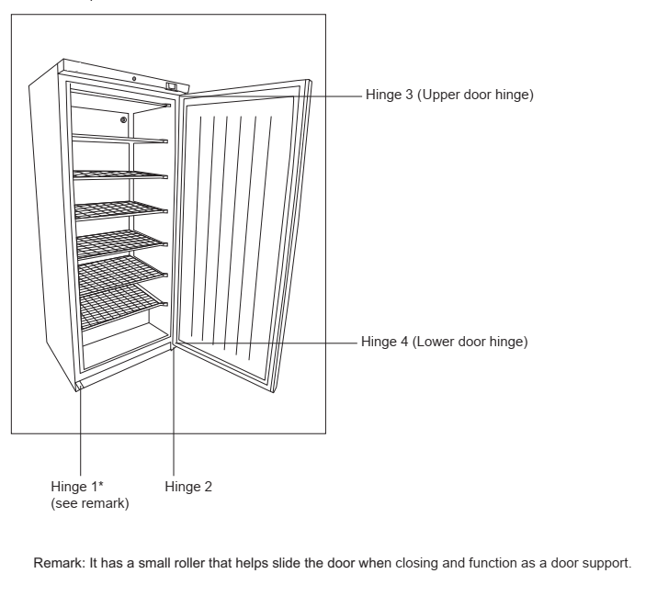
Remark: It has a small roller that helps slide the door when closing and function as a door support.

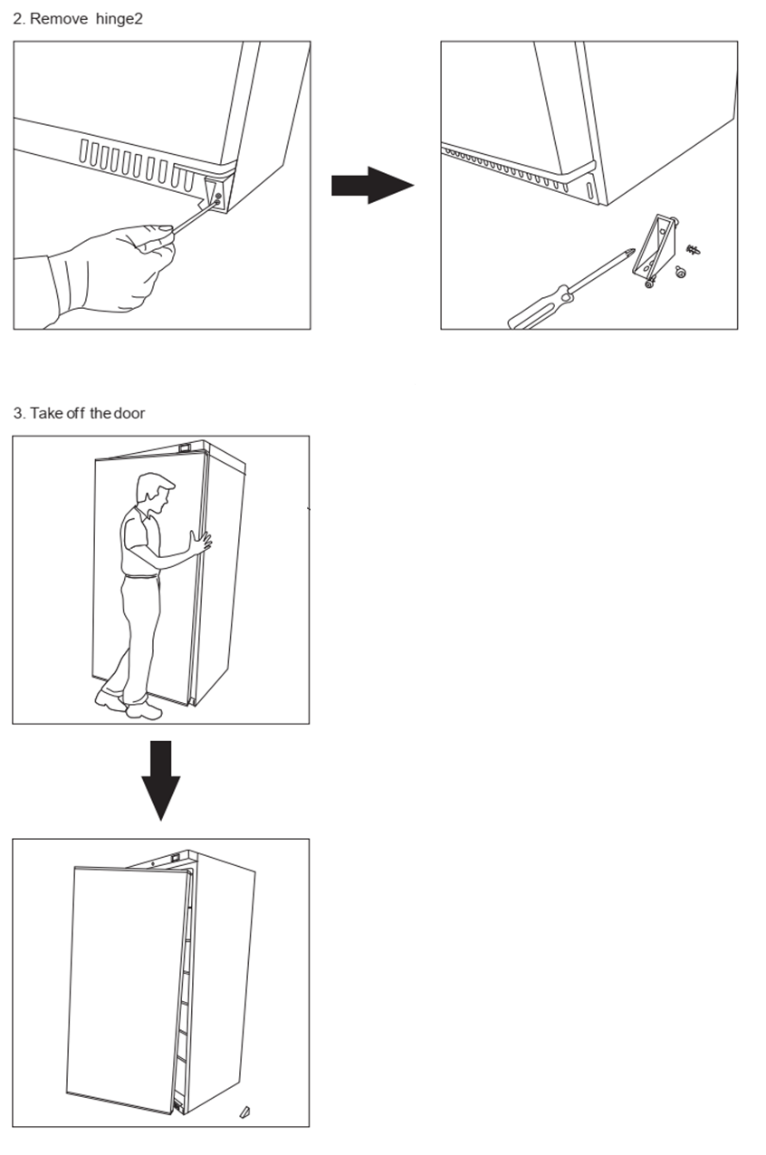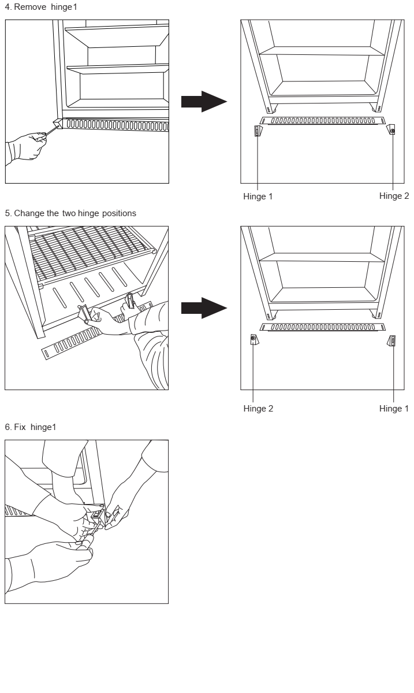

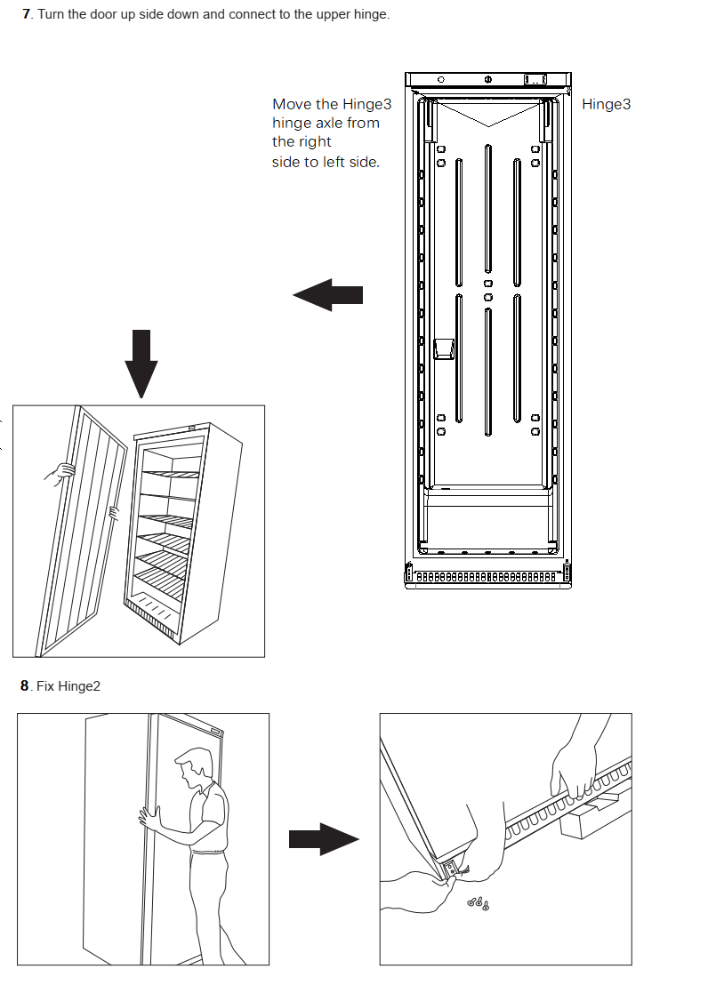

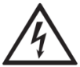
Cleaning, Care & Maintenance
Before cleaning, switch off the cabinet and disconnect from the mains.
The cabinet should be kept clean using a mild soap solution. Do not use abrasive cleansers. The plastic parts cannot withstand boiling water (max. temperature +85 °C).
When regular cleaning is performed, be sure to wipe clean the rubber door gasket to ensure any sticky substances are removed that would otherwise damage the gasket.
The condenser fan air outlet above the compressor must be free of leaves, paper etc. to ensure normal operation of the cabinet.
The condenser on the back of the cabinet must be regularly cleaned as well. This is best done with a vacuum cleaner and a brush.
Routine maintenance
Switch off and disconnect from the power supply before cleaning.
• Clean the enclosure and interior of the appliance as often as possible.
• Clean the unit with moist cloth. Never allow the switch, control panel, cable or plug to get wet.
• Do not use abrasive cleaning agents. These can leave harmful residues. Use only mild soapy water.
• Clean the door seal with water only.
• Ensure that no cleaning water penetrates into the electrical components.
• Must not be cleaned by a water jet.
• Always wipe dry after cleaning with soft cloth.
• Take care when cleaning the rear of the appliance.
• An agent or qualified technician must carry out repairs if required.
• If the appliance is to be left inactive for long periods, unplug the appliance after having turned the switch to OFF position, empty the refrigerating compartment and clean thoroughly. Please leave the door open to avoid the development of odor and mildew.
Special maintenance
The instructions given in the following paragraph are for SKILLED PERSON.
Periodic Operations:
• Periodically clean the condenser using suitable tools (vacuum cleaner or soft brushes).
• Check that the electrical connections are not loose.
• Check that the thermostat and the sensor are in proper working order.
• Periodically cleaning the condenser can extend the life of the appliance.
• Recommend that an agent or qualified technician clean the condenser.
• The key to the electrical cabinet should be kept out of the reach of children .
• Only use the key to open the lock.

Trouble shooting
If your Refrigerator appliance develop a fault, please check the following table
Fault | Probable Cause | Action
The appliance is not working | The unit is not switched on | Check that the unit is plugged in correctly and switched on
 | Plug and/or lead are damaged | Call our agent or qualified technician
 | Power supply | Check power supply
 | Internal wiring fault | Call our agent or qualified technician
The appliance turns on, but the temperature is too high/low | Too much ice on the evaporator | Defrost the appliance
 | Condenser blocked with dust | Clean the condenser thoroughly
 | The door is not shut properly | Check that the door is shut and seals are not damaged
 | Appliance is located near a heat source, or air flow to the condenser is blocked | Move the refrigerator to a more suitable location
 | Ambient temperature is too high | Increase ventilation or move appliance to a cooler position
 | Unsuitable foodstuffs are being stored in the appliance | Remove any excessive hot foodstuffs or blockages to the fan
 | Appliance is overloaded | Reduce the amount of food stored in the appliance
The appliance is leaking water  (Refrigerator) | The appliance is not properly levelled | Adjust the screw feet to level the appliance
 | The discharge outlet is blocked | Clear the discharge outlet
 | The water container is damaged | Call our agent or qualified technician
The appliance is unusually loud | Loose nut/ screw | Check and tighten all nuts and screws
 | The appliance has not been installed in a level or stable position | Check installation position and change if necessary

Disposal
If the cabinet is no longer of use and you wish to dispose of it, please do so in an environmentally correct way. There may be special requirements or conditions. You can obtain information on the disposal of refrigeration appliances from:
- Your supplier
- Government authorities (The local council, Ministry of the Environment, etc.)
Technical data
Please refer to the information indicated on the product. You will find the information on the rating label on the back of the unit as well as inside the cooling compartment.The circuit diagram is displayed on the back of the unit as well as inside the cooling compartment.
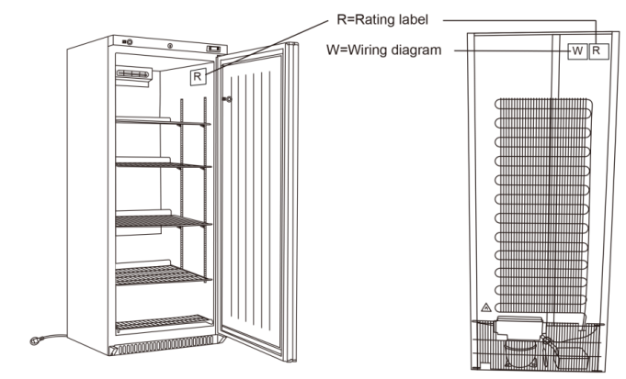

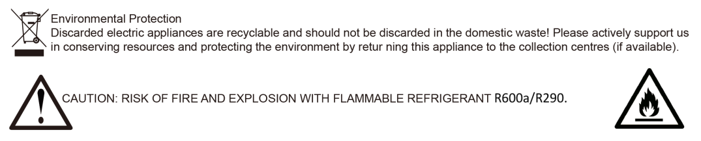

WARRANTY
A statutory warranty applies for this product.
Damages caused by wrong treatment or operation, by false placement or storage, improper connection or installation, as well as force or other external influences are not covered by this warranty. We recommend careful reading of the operating instructions as it contains important information.
Note:
1.In case this product does not function correctly, please firstly check if there are other reasons, e.g. for electrical appliances interruption of the power supply, or generally incorrect handling are the cause.
2.Please note that, where possible, the following documents or rather information should be provided together with your faulty product:
-Purchase receipt
-Model description/Type/Brand
-Describe the fault and problem as detailed as possible
In the case of a claim for guarantee or defects, please contact the seller.

