|  |  |
| --- | --- |
|  | Blast Chiller / Freezer |
| Instruction Manual |

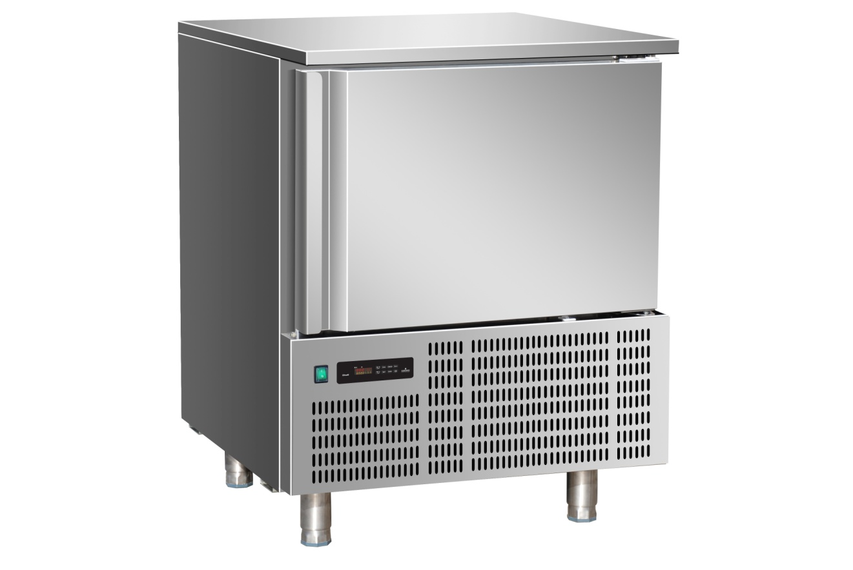

**Safety Tips**

* Position on a flat, stable surface.
* A service agent/qualified technician should carry out installation and any repairs if required.
* Do not remove any components or service panels on this product.
* Consult Local and National Standards to comply with the following:
  + Health and Safety at Work Legislation
  + EN Codes of Practice
  + Fire Precautions
  + IEE Wiring Regulations
  + Building Regulations
* DO NOT use jet/pressure washers to clean the appliance.
* DO NOT use the appliance outside.
* DO NOT use this appliance to store medical supplies.
* DO NOT use electrical appliances inside the appliance (e.g. heaters, ice-cream makers etc.).
* DO NOT allow oil or fat to come into contact with the plastic components or door seal. Clean immediately if contact occurs.
* Always carry, store and handle the appliance in a vertical position and move by holding the base of the appliance.
* Always switch off and disconnect the power supply to the unit before cleaning.
* Keep all packaging away from children. Dispose of the packaging in accordance with the regulations of local authorities.
* The appliance is not to be used by children or persons with reduced physical, sensory or mental capabilities, or lack of experience or knowledge, unless they have been given supervision or instruction
* If the power cord is damaged, it must be replaced by a agent or a recommended qualified technician in order to avoid a hazard.

**Introduction**

Please take a few moments to carefully read through this manual. Correct maintenance and operation of this machine will provide the best possible performance from your product.

**Pack Contents**

The following is included:

* Blast Chiller /Freezer
* Instruction manual

Should you find any damage as a result of transit, please contact your dealer immediately.

**Installation**

**Note: If the appliance has not been stored or moved in an upright position, let it stand upright for approximately 12 hours before operation. If in doubt allow the appliance to stand.**

1. Remove the appliance from the packaging. Make sure that all protective plastic film and coatings are thoroughly removed from all surfaces
2. Maintain a distance of 20cm (7 inches) between the unit and walls or other objects for ventilation. Increase the distance of the object is a heat source. Do not block front ventilation grills.

**Note: Before using the appliance for the first time, clean the shelves and interior with soapy water.**

1. Set the brakes on the castors to keep the appliance in position.

**Operation**

It is important that food entering the Blast Chiller/Freezer does not exceed a temperature of 90oC.

It is recommended that metal containers / trays are used as other materials such as plastic or polystyrene containers will act as an insulator and extend blast chilling times.

Sufficient space must be left between products in order to guarantee a sufficient flow of cold air. Ensure product is not in contact with the internal walls of the unit, and leave sufficient gaps between trays.

Never obstruct the inlet of the evaporator fans.

Products that are more difficult to chill because of their composition and size should be placed in the centre of the unit.

Blast chilling data refers to standard products (low fat content) with a thickness below 50 mm: therefore avoid overlaying products on trays or the insertion of pieces with a much higher thickness, as this will lead to an extension of blast chilling times. Always distribute the product well on the trays and in the case of thick pieces decrease the amount to blast chill.

Limit the number of times and the duration of time the doors are opened.

The chiller should be used for storage for short periods only.

When removing product that has undergone blast chilling/shock freezing, always wear gloves to protect the hands from cold burns.

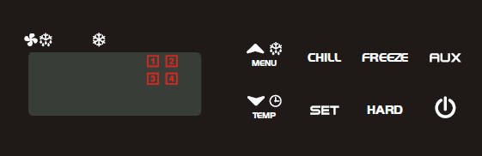**C:\Users\ashleyh\AppData\Local\Microsoft\Windows\Temporary Internet Files\Content.Word\controller 1-2.bmpTurning on**

In order to switch the unit on, press button. This will place the unit on standby whilst waiting for the cycle to be selected.

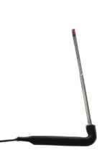

**Inserting the food insert probe**

Before selecting which cycle to use, the probe must be inserted into the food product. This allows the internal temperature of the food product to be measured. It is important that the probe is correctly connected to the unit, or an alarm will activate and the unit will not function.

**Note: To prevent bacterial contamination or contamination of any other biological nature, the needle probe must be disinfected after use.**

**Selecting a cycle**

The number on the operating panel corresponds to which cycle is selected. To alternate the cycle between hard and soft, press the ‘hard’ button. Once the required cycle’s number is showing, select which type of operation you would like by using the ‘freeze’ or ‘chill’ button. Confirm your choice by pressing the same button once again. This will start the cycle.

|  |
| --- |
| **Cycle 1** – soft chilling for delicate products (e.g. patisseries and vegetables) |
| 1. After switching on the unit, icons and will flash. 2. C:\Users\ashleyh\AppData\Local\Microsoft\Windows\Temporary Internet Files\Content.Word\controller 1-2.bmpPress and release the button. Icon will remain on. 3. C:\Users\ashleyh\AppData\Local\Microsoft\Windows\Temporary Internet Files\Content.Word\controller 1-2.bmpTo start the cycle press and release the button. |
| **Cycle 2** – soft freezing for delicate products (e.g. patisseries and vegetables) |
| 1. After switching on the unit, icons and will flash. 2. C:\Users\ashleyh\AppData\Local\Microsoft\Windows\Temporary Internet Files\Content.Word\controller 1-2.bmpPress and release the button. Icon will remain on. 3. C:\Users\ashleyh\AppData\Local\Microsoft\Windows\Temporary Internet Files\Content.Word\controller 1-2.bmpTo start the cycle press and release the C:\Users\ashleyh\AppData\Local\Microsoft\Windows\Temporary Internet Files\Content.Word\controller 1-2.bmp button. |
| **Cycle 3** – hard chilling for general purpose foods (e.g. meat, pies and lasagne) |
| 1. After switching on the unit, icons and will flash. 2. C:\Users\ashleyh\AppData\Local\Microsoft\Windows\Temporary Internet Files\Content.Word\controller 1-2.bmpPress the button. Icons and will turn on, indicating that hard chilling and hard freezing can be selected. 3. C:\Users\ashleyh\AppData\Local\Microsoft\Windows\Temporary Internet Files\Content.Word\controller 1-2.bmpPress and release the button. The icon will remain on. 4. C:\Users\ashleyh\AppData\Local\Microsoft\Windows\Temporary Internet Files\Content.Word\controller 1-2.bmpTo start the cycle press and release the button. |
| **Cycle 4** – hard freezing for general purpose foods (e.g. meat, pies and lasagne) |
| 1. After switching on the unit, icons and will flash. 2. C:\Users\ashleyh\AppData\Local\Microsoft\Windows\Temporary Internet Files\Content.Word\controller 1-2.bmpPress the button. Icons and will turn on, indicating that hard chilling and hard freezing can be selected. 3. C:\Users\ashleyh\AppData\Local\Microsoft\Windows\Temporary Internet Files\Content.Word\controller 1-2.bmpPress and release the button. The icon will remain on. 4. C:\Users\ashleyh\AppData\Local\Microsoft\Windows\Temporary Internet Files\Content.Word\controller 1-2.bmpTo start the cycle press and release the button. |

**Temporarily stopping the Running cycle**

1. C:\Users\ashleyh\AppData\Local\Microsoft\Windows\Temporary Internet Files\Content.Word\controller 1-2.bmpC:\Users\ashleyh\AppData\Local\Microsoft\Windows\Temporary Internet Files\Content.Word\controller 1-2.bmpIf you have selected a chill operation, press and release the button. If you have selected a freeze operation, press and release the button.
2. The compressor and the fan will be stopped and the icon for the current cycle starts to flash.
3. To restart the cycle press and release the same key used to stop the cycle. The cycle will restart from the same point at which it was interrupted. There will be a 2 minute delay after stopping the generator in order to prevent the unit overheating.
4. If the cycle is not manually restarted the Chiller will automatically restart after 20 minutes.

**How to stop a cycle**

C:\Users\ashleyh\AppData\Local\Microsoft\Windows\Temporary Internet Files\Content.Word\controller 1-2.bmpC:\Users\ashleyh\AppData\Local\Microsoft\Windows\Temporary Internet Files\Content.Word\controller 1-2.bmpIf you have selected a chill operation, press and release the key. If you have selected a freeze operation, press and release the key. The unit will then switch off.

**When a Cycle is Running**

**Display Temperatures**

The upper display (in red) shows the temperature of the inside of the cabinet. The bottom display (in yellow) shows the temperature of the insert probe (ip1).

Probes ip2 & ip3 are not included, if displayed press the down key until ip1 is displayed.

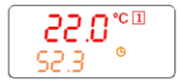

Once the cycle has finished, the unit will beep to indicate the food has reached its desired temperature.

**Manual Defrost**

Assure that no cycle is active and that the hold mode function is not running.

* Hold and press the UP key for few seconds.

**Note: The defrost will not be done if the temperature detected by the evaporator probe is higher than the stop defrost temperature parameter.**

**C:\Users\ashleyh\AppData\Local\Microsoft\Windows\Temporary Internet Files\Content.Word\New Picture.bmpLocking the Keyboard**

* To lock & unlock the keyboard, hold down both up and down keys together

**Resetting Date and Time**

C:\Users\ashleyh\AppData\Local\Microsoft\Windows\Temporary Internet Files\Content.Word\New Picture.bmp

1. To reset the clock data, press and hold button for 5 seconds. This will display the date and time parameters.
2. C:\Users\ashleyh\AppData\Local\Microsoft\Windows\Temporary Internet Files\Content.Word\New Picture.bmpC:\Users\ashleyh\AppData\Local\Microsoft\Windows\Temporary Internet Files\Content.Word\New Picture.bmpC:\Users\ashleyh\AppData\Local\Microsoft\Windows\Temporary Internet Files\Content.Word\New Picture.bmpPress the key. The value will start to flash.
3. C:\Users\ashleyh\AppData\Local\Microsoft\Windows\Temporary Internet Files\Content.Word\New Picture.bmpEdit the value using the and buttons.
4. Press to select the new value and move onto the next value.

**Cleaning the evaporator**

**Please ensure that the Blast Chiller is switched off and unplugged prior to cleaning**

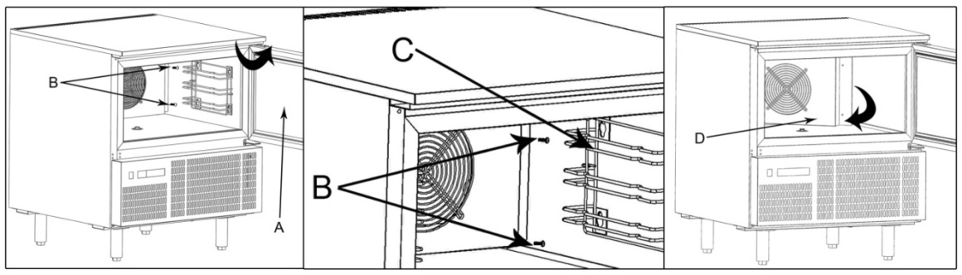

* Clean the evaporator **periodically.**
* As the fins of the evaporator are very sharp. Always wear protective gloves for the next phases
* Only a brush must be used for cleaning: do not use jets of liquid or sharp instruments.
* To access the evaporator proceed as follows:

1. Open the door (A) of the appliance.
2. Loosen the two screws (B) on the right of the deflector.
3. Remove the runner (C).
4. Turn the deflector (D) to the left.

**Cleaning the condenser**

**Please ensure that the Blast Chiller is switched off and unplugged prior to cleaning**

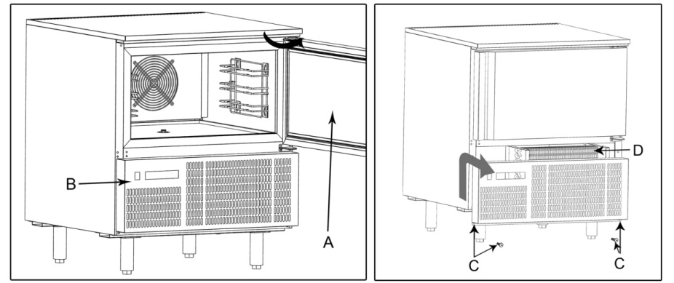

* Clean the condenser **periodically**.
* As the fins of the condenser are very sharp, always wear protective gloves for the next phases. Use protective masks and glasses in the presence of dust.
* Whenever the condenser has a deposit of dust in correspondence with the fins, this can be removed using a suction device or with a brush applied, using a vertical movement along the direction of the fins.
* No other instruments must be used, which may deform the fins and therefore the efficiency of the appliance.
* To clean, proceed as follows:

1. Open the door (A) of the appliances.
2. Remove the lower panel (B) from the technical compartment: to do this, remove the screw fasteners (C).
3. It is now possible to clean the finned part of the condenser (D) using suitable tools and protection devices.
4. After cleaning, close the control panel and fix it with the screws removed beforehand.

**Troubleshooting**

If your appliance develops a fault, please check the following table before making a call to the helpline or your local retailer.

|  |  |  |
| --- | --- | --- |
| **Fault** | **Probable Cause** | **Required Action** |
| The appliance is not  working | The unit is not switched on | Check the unit is plugged in correctly and switched on |
| Plug and lead are damaged | Call agent or qualified Technician |
| Fuse in the plug has blown | Replace the fuse |
| Power supply | Check power supply |
| Internal wiring fault | Call agent or qualified Technician |
| The appliance is leaking  water | The appliance is not properly leveled | Adjust the screw feet to level the appliance |
| The drain is blocked | Clear the drain |
| Movement of water to the drain is  Obstructed | Clear the floor of the appliance |
| The water container is damaged if water is leaking from back of container | Call agent |
| The appliance is  unusually loud | The appliance has not been installed in a level or stable position | Check installation position and change if necessary |
| Loose nut/screw | Check and tighten all nuts and screws |
| The appliance is not chilling | Wrong program | Change program – see controller manual |
| The filter is blocked | Clean filters |
| Temperature of food is not being detected | The food insert probe is broken | Purchase a new food insert probe from your Distributor. Code: AE222 |
| Food has freezer burns after removing from unit | The cycle is not the correct one to be using for the type of food | Change cycle from hard freeze to soft freeze (see page no. 4) |
| The appliance is beeping and there is a message appearing on the operating panel | There is a problem with the unit being indicated by the control alarm signal | See table below |

|  |  |  |
| --- | --- | --- |
| **Operating Panel Message** | **Meaning** | **Required Action** |
| “EE” | Data or memory failure | Call agent or qualified technician |
| “rPF” | Thermostat Probe failure | Call agent or qualified technician |
| “EPF” | Evaporator Probe failure | Call agent or qualified technician |
| “i1P”  “i2P”  “i3P” | Insert probe 1, 2, 3, failure | Ensure insert probe has not become disconnected from the socket. |
| “rtC” | Clock data lost | Reset date and time (see page no.5) |
| “rtF” | Clock failure | Reset date and time (see page no.5) |
| “HA” | Maximum temperature alarm | Alarm will automatically stop as soon as the thermostat values returns to normal values |
| “LA” | Minimum temperature alarm | Alarm will automatically stop as soon as the thermostat values returns to normal values |
| “FF” | Fast freezing interrupted by short power failure | Call agent or qualified technician |
| “PFA” | Fast freezing interrupted by long power failure | Freezing cycle will restart from the current phase. |
| “OCF” | Maximum cycle time has been exceeded | Product will continue to operate. Press any key to deactivate alarm. |
| “EA” | External alarm | Call agent or qualified technician |
| “CA” | Serious external alarm | Call agent or qualified technician |
| “dA” | Door open alarm | Ensure door is closed fully |

**Electrical Wiring**

The plug is to be connected to a suitable mains socket.

The appliances are wired as follows:

* Live wire (coloured brown) to terminal marked L
* Neutral wire (coloured blue) to terminal marked N
* Earth wire (coloured green/yellow) to terminal marked E

All appliances must be earthed, using a dedicated earthing circuit.

If in doubt consult a qualified electrician.

Electrical isolation points must be kept clear of any obstructions. In the event of any emergency disconnection being required they must be readily accessible.

**Disposal**

EU regulations require refrigeration product to be disposed of by specialist companies who remove or recycle all gasses, metal and plastic components.

Consult your local waste collection authority regarding disposal of your appliance. Local authorities are not obliged to dispose of commercial refrigeration equipment but may be able to offer advice on how to dispose of the equipment locally.

Alternatively call the Agent helpline for details of national disposal companies within the EU.

**Compliance**

The WEEE logo on this product or its documentation indicates that the product must not be disposed of as household waste. To help prevent possible harm to human health and/or the environment, the product must be disposed of in an approved and environmentally safe recycling process. For further information on how to dispose of this product correctly, contact the product supplier, or the local authority responsible for waste disposal in your area.

All parts have undergone strict product testing in order to comply with regulatory standards and specifications set by international, independent, and federal authorities.