banks

**BANKS SERIES GAS FRYERS**

***USER MANUAL***

**MODELS:**

**GF30L GF30N**

**GF40L GF40N**

**GF50L GF50N**



**Intertek**

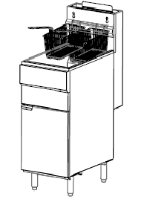

**(PLEASE RETAIN THIS MANUAL FOR FUTURE REFERENCE)**

**Post in a prominent location. Instructions to be followed in the events of the user smelling gas.**

|  |  |
| --- | --- |
| Model | Dimensions (mm) |
| GF30L GF40N | 394x769x1196 |
| GF40L GF40N | 394x769x1196 |
| GF50L GF50N | 530x769x1196 |

**TABLE OF CONTENTS**

IMPORTANT FOR YOUR SAFETY........................................................................................................3

INTRODUCTION.................................................................................................................................4

ORDERING PARTS..............................................................................................................................4

FRYER SPECIFICATIONS.....................................................................................................................4

UNPACKING.......................................................................................................................................5

INSTALLATION...................................................................................................................................5

CLEARANCE........................................................................................................................................5

LOCATION..........................................................................................................................................6

CODES AND STANDARDS...................................................................................................................6

ASSEMBLY.........................................................................................................................................6

GAS CONNECTION AND SUPPLY........................................................................................................7

GAS PRESSURE..................................................................................................................................7

TEST GAS SUPPLY..............................................................................................................................7

FRYERS WITH CASTORS....................................................................................................................8

LEVELLING THE FRYER......................................................................................................................8

OVER-TEMPERATURE SHUTDOWN..................................................................................................8

BEFORE FIRST USE............................................................................................................................9

FILLING TANK WITH OIL....................................................................................................................10

LIGHTING THE PILOT.........................................................................................................................11

FRYER OPERATION...........................................................................................................................12

TURNING OFF THE FRYER.................................................................................................................12

EXTENDED SHUTDOWN....................................................................................................................12

BASIC FRYING INSTRUCTIONS..........................................................................................................12

FRY BASKET GUIDELINES..................................................................................................................13

EXTENDED OIL LIFE............................................................................................................................13

DRAINING THE TANK.........................................................................................................................14

DAILY FILTERING - ALL MODELS.........................................................................................................14

CLEANING...........................................................................................................................................15

BOIL OUT PROCEDURE.......................................................................................................................16

MAINTENANCE...................................................................................................................................16

FLUE VENT INSPECTION......................................................................................................................17

TROUBLESHOOTING CHART...............................................................................................................17

GUARANTEE........................................................................................................................................18

**IMPORTANT FOR YOUR SAFETY**

**THIS MANUAL HAS BEEN PREPARED FOR PERSONNEL QUALIFIED TO INSTAL GAS EQUIPMENT IN THE COUNTRY OF INSTALLATION. THIS PERSON SHOULD PERFORM THE INITIAL COMMISSIONING AND ADJUSTMENTS OF THE EQUIPMENT COVERED BY THIS MANUAL.**

**POST IN A PROMINENT LOCATION. PLEASE FOLLOW THESE INSTRUCTIONS IN THE EVENT OF A GAS LEAK. THIS INFORMATION CAN BE OBTAINED FROM THE LOCAL GAS SUPPLIER.**

**IMPORTANT**

**IF A GAS ODOUR IS DETECTED, SHUT DOWN ALL GAS UNITS AT THE MAIN SHUT OFF VALVE AND CONTACT THE LOCAL GAS COMPANY OR GAS SUPPLIER FOR IMMEDIATE SERVICE.**

**FOR YOUR SAFETY**

**DO NOT STORE OR USE PETROL OR OTHER FLAMMABLE VAPOURS OR LIQUIDS IN THE VICINITY OF THIS OR ANY OTHER GAS APPLIANCE.**

**Improper installation, adjustment, alteration, service or maintenance will invalidate warranty and may cause property damage, injury or death.**

**Read the installation, operating and maintenance instructions thoroughly before installing or servicing this equipment.**

**INTRODUCTION**

**GENERAL**

Banks Fryers are produced with quality workmanship and materials.

Proper installation, usage and maintenance will result in years of satisfactory performance.

Before installing the fryer, thoroughly read this manual and carefully follow all instructions.

This manual is applicable to models listed on the cover page.

Procedures in this manual will apply to all models unless specified. Pictures and illustrations can be of any model unless the picture or illustration needs to be model specific.

**ORDERING PARTS**

Customers may order parts directly from their local authorised service centre. Please call 0845 872 5000 (UK) or 1890 602000 (IRL) to find your local distributor.

Please provide the model number, serial number, gas type, part needed, item part number (if known) and quantity required.

**FRYER SPECIFICATIONS**

|  |  |  |  |  |  |  |  |  |
| --- | --- | --- | --- | --- | --- | --- | --- | --- |
| **Model** | **Gas**  **Category** | **Supply**  **Pressure**  **(mbar)** | **Burner**  **Pressure**  **(mbar)** | **No**  **of**  **Burners** | **Burner**  **Orifice (mm)** | **Pliot**  **Orifice (mm)** | **Oil Capacity**  **(litres)** | **BTU/hr** |
| **GF30N** | **G20 - NAT** | **20** | **20** | **3** | **210 (2.1)** | **45 (0.45)** | **18** | **82,000** |
| **GF30L** | **G31 - LPG** | **37** | **37** | **3** | **150 (1.5)** | **40 (0.40)** | **18** | **82,000** |
| **GF40N** | **G20 - NAT** | **20** | **20** | **4** | **210 (2.1)** | **45 (0.45)** | **22.5** | **109,200** |
| **GF40L** | **G31 - LPG** | **37** | **37** | **4** | **150 (1.5)** | **40 (0.40)** | **22.5** | **109,200** |
| **GF50N** | **G20 - NAT** | **20** | **20** | **5** | **210 (2.1)** | **45 (0.45)** | **31.5** | **136,500** |
| **GF50L** | **G31 - LPG** | **37** | **37** | **5** | **150 (1.5)** | **40 (0.40)** | **31.5** | **136,500** |

**UNPACKING**

This fryer was carefully inspected before leaving the factory. Immediately unpack the fryer and check for possible damage. If the fryer is damaged, save the packaging material and contact the carrier immediately. If the goods are signed for and not checked, the responsibility is on the person who signed the delivery docket, even if the packaging looks ok, but damage is subsequently found. No claim can be followed in this case.

Check that the following have been included:

Crumb rack Drain Pipe Extension

Basket Hanger Twin Fry Baskets (2)

Legs Manual & warranty.

Do not use the door or its handle to lift the fryer.

**INSTALLATION**

Before installing the fryer, verify that the type of gas (natural or propane) agrees with the specifications on the fryer data plate, which is located on the inside of the door panel. Make sure that the fryer is configured for the proper elevation.

Record your fryer model, device and serial number for future reference in the space provided below. This information can be found on the fryer data plate.

**Fryer Model No: _____________________________________**

**Serial No:___________________________________________**

**Clearances**

Minimum clearance from combustible construction:

6” (15cm) from the sides of the fryer

6” (15cm) from the back of the fryer

The fryer must not be installed on combustible floors.

Minimum clearance from non combustible construction:

6” (15cm) from the sides of the fryer

6” (15cm) from the back of the fryer

Between the fryer & open-top flame units:

16” (41cm)

Allow space for servicing and operation.

**Location**

* Install fryer in an area with sufficient air supply for gas combustion at fryer burners – 24mm3/hr minimum
* Do not obstruct the flow of combustion or ventilation air
* Provide adequate clearance for air openings into the combustion chamber
* Do not permit fans to blow directly onto fryer
* Avoid wall-type fans, which create cross-currents within a room
* Avoid open windows next to the sides or back of the fryer
* Do not obstruct or block the appliance flue
* Do not connect the extraction system directly to the appliance flue

**CODES AND STANDARDS**

Installation of appliance shall comply with local Gas, Health and Safety requirements, in the country of installation.

* Gas Safety (Installation & Use) Regulations
* Local & National Building Regulations
* Health & Safety at Work Act
* Institution of Gas Engineers Publications IGE/IPI, IGE/UP/2, IGE/UP/4
* Fire Safety Act
* BS5440: Extraction, air supply for gas appliance
* BS6175 / BS5440-2
* Ireland – IS820 – Non Domestic Gas Installations

**ASSEMBLY**

The fryer must be restrained to prevent tipping and the splashing of hot liquid. The means of restraint may be the manner of installation, installing the fryer in an alcove or by separate means such as adequate ties.

**NOTE: The gas supply pressure at the gas inlet to the appliance should be equal to the rating on the fryer data plate.**

Locate the fryer under a hood with adequate connection to an exhaust duct.

The hood must extend 6” (15cm) beyond the fryer on both sides.

Clearance above the fryer should be adequate for combustion of by products to be removed efficiently.

An 18” (46cm) minimum clearance should be maintained between the flue vent and the filters of the hood ventilation system.

Never make flue extract connections directly onto the fryer flue.

Do not obstruct the flow of the gasses from the appliance.

Proper air balance should be maintained in the room.

**GAS CONNECTION AND SUPPLY**

The appliance must be installed, tested and commissioned by a qualified gas technician to the gas safety regulations in the country of installation.

All gas supply connections and any pipe joint compound must be resistant to the action of propane gasses.

* Check that gas supply corresponds to that specified on the data plate of the appliance
* Connection is at the back of the unit via 1/2” BSPT male tread
* Suitable quick release commercial gas hose to be used. Domestic hoses are not suitable
* Isolating valve must be fitted close to the unit for emergency shut down and servicing
* Pressure test the appliance (soundness test) before connecting the gas supply
* Test for leaks

Make sure the pipes are clean and free from obstructions, dirt and piping compound.

**Prior to lighting, check all joints in the gas supply line for leaks.**

**Use soap and water solution or other gas leak detection equipment**

After piping has been checked for leaks, fully purge gas pipes to remove air.

**WARNINGS** 

* Do not use a naked flame to check for gas leaks
* Make sure the fryer tank is filled with oil before lighting the burners, otherwise the tank will be damaged & invalidate warranty
* Installation of appliance must be carried out by a qualified person in accordance with Gas Safety Regulations in the country of installation.

**GAS PRESSURE (ALL MODELS):**

The working gas pressure should be set at 20mbar (millibar) of pressure for natural gas and 37mbar of pressure for propane gas. If the incoming pressure is above these values, an additional pressure regulator must be installed.

**TESTING THE GAS SUPPLY PIPING SYSTEM:**

When test pressures exceed nominal values, the fryer and its individual shut off valve must be disconnected from the gas supply piping system.

When test pressures are below nominal values, the fryer must be isolated from the gas supply piping system by closing its individual shut off valve.

**FRYERS WITH CASTORS:**

The fryer must be installed with the two castors fitted at the rear, if they are provided with the fryer.

When installing a quick connect gas hose, you must also install a means for limiting the movement of the fryer. This device will prevent the gas line or quick disconnect hose from being strained.

The restraining device must be attached to the cut out on the back panel.

See illustration for location.

The fryer must be installed with a gas connector complying with local gas safety regulations.

**LEVELLING THE FRYER**

Check the level of the fryer by placing a level on top of the fryer after gas connections have been made.

Ensure that the fryer is level front-to-back and side-to-side in the final installed position.



**Hot oil and parts can cause burns. Use care when operating, cleaning and servicing the fryer.**



**Spilling hot frying compound can cause severe burns. Do not move fryer without draining all frying compound from the tank.**

**OVER-TERMPERATURE SHUTDOWN**

If the oil becomes over heated, a high-temperature shutoff device will turn the gas off to the burners and extinguish the pilot.

If the fryer shuts down due to overheating, DO NOT re-light the pilot until the oil temperature is below 300°F (149°C).

If an overheating situation persists, contact your local Banks authorised service agent.

**BEFORE FIRST USE**

**Cleaning**

New units are wiped down at the factory to remove any visible signs of dirt, oil, grease etc., remaining from the manufacturing process.

Before any food preparation, thoroughly wipe protective oil from all surface parts and the tank interior with hot soapy water to remove any film residue and dust or debris.



Do not use chlorine or sulphate/sulphide cleaners.

Wash any accessories shipped with unit.

Rinse fryer and accessories thoroughly and drain the fryer.

Wipe tank completely dry with a soft, clean cloth.

**FILLING THE TANK WITH OIL**



Solid shortening should NOT be used with fryers.

Melting solid shortening will damage the tank and void the warranty.



Close the drain valve.

Fill the fryer tank with oil.

Oil level will expand when heated. Do not fill the tank past the MAX line.

Add fresh oil when needed to maintain oil level.

**LIGHTING THE PILOT**

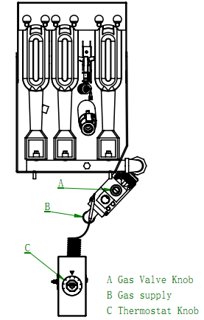

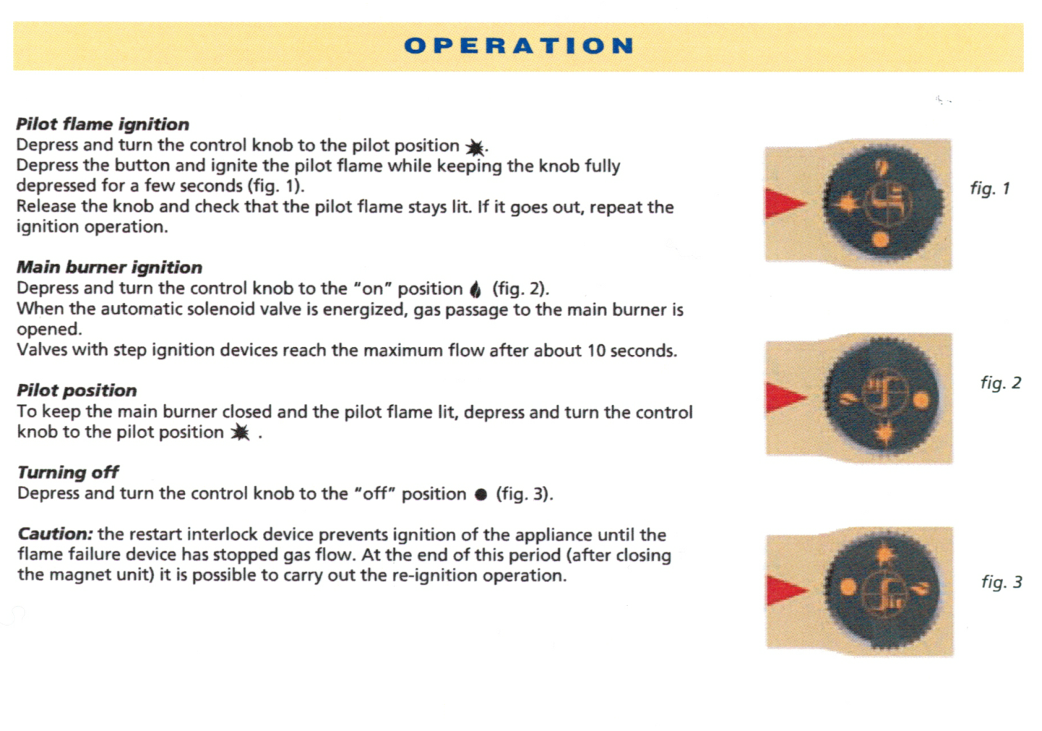

When the fryer is lit, proceed with all the relevant gas regulation checks, including; gas leak tests, correct operation of the gas valve, correct operation of the thermocouple, correct temperature of the oil when compared with the temperature knob setting. If the oil temperature does not equal the temperature knob setting, calibrate the thermostat until the correct value is reached.

**FRYER OPERATION**

Set the temperature knob to the desired frying temperature.

After the set temperature has been reached, the thermostat shuts off the gas flow to the burners.

The pilot remains lit. The burners will cycle on and off, maintaining the set temperature.

**TURNING OFF THE FRYER**

1. Turn the thermostat OFF
2. To keep pilot lit, turn the gas valve to the Pilot position.
3. To shut off all gas to the system, including the pilot, turn the gas valve knob to the OFF position.

**EXTENDED SHUTDOWN**

1. Turn the thermostat knob to OFF
2. Push in the pilot knob and turn to OFF
3. Thoroughly drain the fryer. Refer to DRAINING THE FRYER
4. Clean the fryer. Refer to CLEANING
5. Turn off the main gas shutoff valve.

**BASIC FRYING INSTRUCTION**

Set the desired temperature and allow the oil to heat up to that temperature before adding produce.

Fry items that are about the same size together, to have the same cooking time.

Drain or wipe dry, raw or wet foods to minimize splatter when lowering into hot oil.

Add fresh oil as needed.

**FRY BASKET GUIDELINES**

Do not overfull baskets (see table for recommended basket capacities below)

Carefully lower basket into oil.

When frying doughnuts and fritters, turn the product once during frying.

When cooking French fries or onion rings, shake the basket several times in a way that does not splatter

the oil.

Batter covered foods should be dropped carefully, one by one, into the oil or basket, away from the operator.

If you use the basket, first dip the basket into the oil to reduce batter build up on basket surfaces.

When frying is completed, remove basket or product.

Hang basket on the rear hanger.

**Fry Basket Capacity:**

GF30, GF40, GF50 recommend pounds per basket are 1.5lbs (0.7 kgs)

**EXTENDING OIL LIFE**

Oil life can be extended by the following guidelines:

Do not salt foods over the fryer.

Use good quality oil.

Filter oil daily (at a minimum)

Replace oil if it becomes poorly flavoured.

Keep equipment and oil clean.

Set the temperature thermostat correctly.

Remove excess moisture and particles from food products before placing into the fryer.

**DRAINING THE TANK**

1. Turn the thermostat to OFF.
2. To keep the pilot lit, turn gas valve to PILOT.
3. Direct the drain spout into the container that you want to drain oil into.
4. Open the drain valve. The oil will drain into the container. When the container is full or the fryer tank is empty, close the drain valve. Repeat this step until the fryer is empty.
5. If desired, perform the weekly clean-out as described under CLEANING.
6. Once tank is completely empty, add new oil and set thermostat to desired temperature.

**DAILY FILTERING**



**Hot oil and hot parts can cause burns. Use care when operating, cleaning and servicing the fryer.**

Filter the oil at least once a day. Refer to the instructions provided with your filtering equipment.

A cold fryer will not drain properly.

Always filter hot oil between 93°C and 120°C.

The oil in the cold zone area will remain hard if the heat is only on for a few minutes.

If necessary, use the clean-out rod to carefully stir the hard oil to an area above the cold zone where it will melt.



**CLEANING**



**Hot oil and hot parts can cause burns. Use care when operating, cleaning and servicing the fryer.**

**Daily**

Clean you fryer regularly with a damp cloth and polish with a soft, dry cloth. If regular cleaning is neglected, grease will be burned onto the fryer and discolorations may form.

Fingerprints are sometimes a problem with highly polished surfaces of stainless steel. They can be minimized by applying a cleaner that will leave a thin oil or wax film.

Clean all exterior surfaces at least once daily.

Use a damp cloth with warm water and a mild soap or detergent.



Do not use chlorine or sulphate/sulfide cleaners

Rinse thoroughly and then polish with a soft dry cloth.

Keep the fryer exterior clean and free of accumulated grease to prevent stubborn stains from forming. This can lead to creating a fire hazard.

Remove discolorations by washing with any detergent or soap and water.

Use a self-soaping, non-metallic scouring pad for particularly stubborn discolorations.

Always rub with the grain of the stainless steel.

Do not use a metallic scouring pad or harsh cleaners.

**BOIL OUT PROCEDURE**

**Weekly or as required:**

1. Drain the tank as described under the section DRAINING THE TANK
2. Once the oil has been drained, flush out scraps and sediment with a small amount of warm oil. Allow the tank to drain thoroughly.
3. Close the drain valve and fill tank with non corrosive, grease dissolving commercial cleaner. Follow the manufacturer’s instructions.



Do not use chlorine or sulphate/sulphide cleaners.

1. Add commercial boil-out solution.

Solution level must be between the MIN and MAX levels on the fryer tank.

1. Set thermostat to the temperature recommended for the solution being used. Allow to simmer for about 15 to 20 minutes.
2. Drain the cleaning solution from the tank.
3. Close the drain valve and refill the tank with water.

Add 1 cup (1/4 L) of vinegar to neutralise alkaline left by the cleaner.

Solution level must be between the MIN and MAX level on the fryer tank.

1. Bring solution to a simmer only, turn the thermostat off.

Allow to stand for a few minutes.

1. Drain the tank according to DRAIN THE TANK.

Rinse thoroughly with clear, hot water.

All traces of cleaner must be removed. Dry the tank thoroughly.

1. Close the drain valve and add oil.

Follow the FILLING THE TANK WITH OIL procedure in this manual.

The fryer is now ready for use.

**MAINTENANCE**

**Hot oil and hot parts can cause burns.**

**The operator must be careful when operating, cleaning and servicing the fryer.**

**Spilling hot fryer oil can cause severe burns.**

**Do not move fryer without draining all frying oil from the tank.**

**The fryer should be restrained to prevent tipping when installed in order to avoid the splashing of hot liquid.**

**FLUE VENT INSPECTION**

When the fryer is cool, inspect manually. Check the flue and clear any obstructions.

**SERVICE IN THE UK & IRELAND**

Contact your local Banks Service Office or call 0845 872 5000 (UK) or 1890 206000 (Ireland) for details of your local Banks Agent.

**Troubleshooting Chart:**

**Problem:** **Possible Cause:**

No heat Thermostat dial not turned on.

Pilot not lit.

Gas supply not turned on.

Wire connections loose (call service)

Wire connections need cleaning (call service)

Thermopile (call service)

Insufficient or too Thermostat dial not set to desired temperature

much heat High limit tripped (call service)

Temperature probe (call service)

Tank will not drain Oil too cold

Drain pipe clogged with debris

**GUARANTEE**

The appliance is covered by a 12 month warranty. The warranty is subject to the appliance being used in accordance with the instructions supplied. The guarantee does not cover damage resulting from misuse, accident or alteration to unit. The guarantee does not cover accidental breakage or damage, or wear and tear from normal use or neglect.

Proof of purchase, model number and serial number will be required in any communication with supplier or manufacturer. Incorrect installation, maintenance or unauthorised service work will invalidate warranty.

This guarantee does not affect your statutory rights.

**Authorised Service Agents:**

We recommend that all servicing be carried out by Authorised Service Agents and we cannot accept responsibility for work carried out to by other persons.

Warranty work will only be undertaken during normal working hours 8.30am to 5.30pm Monday to Friday