Original instruction

INSTRUCTION MANUAL
Blast Chiller Cabinets


Please read the user’s manual before you use this product

Blast Chiller Cabinets
Installation, use and maintenance instructions
1. INTRODUCTION 2
2. The manufacturer cannot be held liable in the following cases: 4
3. TRANSPORTATION AND STORAGE 4
4. COMMISSIONING 4
4.1 POSITIONING 4
4.2 INITIAL CLEANING 6
4.3 Electrical connection 6
4.4 CONNECTION TO DRAINS 6
5. TECHNICAL CHARACTERISTICS 6
5.1 NOISE AND VIBRATION 6
5.2 POSSIBLE USAGES 7
6. USAGE FOR CAREL 8
6.1 ACTION 8
6.2 Meaning of the button 8
6.3 Selecting the BLAST CHILLING cycle 9
6.4 How to access and set parameters 10
6.5 Accessing the parameters divided by functional blocks 11
6.6 Directly accessing the parameters by selecting the category 11
6.7 Alarms with manual reset 11
6.8 HACCP function 11
6.9 Procedure for setting the default parameter values 11
7. USAGE FOR DIXELL 12
7.1 QUICK REFERENCE GUIDE 12
7.1.2 KEY COMBINATIONS 13
7.1.3 MEANING OF THE LEDS 13
7.2 CHILLING\ FREEZING CYCLES 14
7.2.1 HOW TO EDIT THE PARAMETERS OF A CHILLING/FREEZING CYCLE 14
8. MANITENANCE 15
8.1 PERIODIC CLEANING 15
8.2 CLEANING OF CONDENSER 15
8.3 PERIOD OF INACTIVITY OF CABINET 15
9. TROUBLE SHOOTING AND REMEDIES 15
9.1 If the cabinet does not operate, make sure that: 15
9.2 If the required temperature is not achieved, make sure that; 15
9.3 If the cabinet leaks water, make that: 16
9.4 If the cabinet is unacceptably noisy, make sure that: 16
9.5 IMPROBABLE RISKS 16
10. SUBSTITUTION OF SPARES 16
11. DISMANTLING 16
Technical Parameters 17
Energy efficiency parameters 17
OFFICIAL APPROVAL AND RULES 19
Summary of operating parameters 20
Signals on the display 20
CORRECT DISPOSAL OF THIS PRODUCT 21

INTRODUCTION
Please read instructions before using this appliance.
IMPORTANT SAFETY INSTRUCTION
▲ To reduce the risk of fire, electric shock, or injury to persons when using your product, basic safety precautions should be followed, including the following.
▲ This appliance must be properly installed and located in accordance with the Installation Instruction before it is used.
▲ Before the appliance is plugged in, ensure that the rated voltage corresponds to the voltage of the electrical system in your home. The power plug should have its own independent socket. Using adapters may cause overheating or burning.
▲ This appliance can be used by children aged from 8 years and above and persons with reduced physical, sensory or mental capabilities or lack of experience and knowledge if they have been given supervision or instruction concerning use of the appliance in a safe way and understand the hazards involved.
▲ Children shall not play with the appliance.
▲ Cleaning and user maintenance shall not be made by children without supervision.
▲ If the supply cord is damaged, it must be replaced by the manufacturer or its service agent or a similarly qualified person in order to avoid a hazard.
▲ Connect to properly grounded outlets only. Avoid the use of extension cords. Do not run cord under carpeting, runners or the like. Arrange cord away from traffic area and where it will not create a tripping hazard.
▲ Always unplug appliance when not in use and before cleaning, adjusting or maintaining this machine. To disconnect appliance, turn switch off and remove plug from power source.
▲ Do not disconnect by pulling on the cord. Always disconnect by grasping and pulling on the plug top.
▲ Do not pull out the cord or touch the power plug with wet hands. Clean water or dust from the power plug and insert it with the ends of the pins securely connected.
▲ Do not use outdoors.
▲ Do not splash water on the appliance. It may cause a malfunction or electric shock.
▲ Do not disassemble, repair or alter the appliance. It may cause fire or abnormal operations, which may lead to injury.
▲ After your fridge-freezer is in operation, do not touch the cold surfaces in the freezer compartment, particularly when hands are damp or wet. Skin may adhere to these extremely cold surfaces.
▲ Never place glass products in the freezer because they may be broken when their inner contents are frozen.
▲ The refrigerant and insulation blowing gas used in the appliance require special disposal procedures. When disposal, please consult with service agent or a similarly qualified person.
▲ Do not store explosive substances such as aerosol cans with a flammable propellant in this appliance.
▲ If you need the electronic version instruction manual, please ask the manufacturer or its service agent .
▲ Max. Load of shelf is 88 lbs.
This instruction manual provides all the necessary information regarding:
▲ use of the refrigerator
▲ technical specifications
▲ installation and handling
▲ operator procedures and instructions
▲ maintenance operation
The manual is to be considered an integral part of the refrigerator and should be stored in a safe place for father consult to permit a good working life of the refrigerator.
The appliance is intended for commercial use only.
▲ WARNING: — Keep clear of obstruction all ventilation openings in the appliance enclosure or in the structure for building-in.
▲ WARNING: — Do not use mechanical devices or other means to accelerate the defrosting process, other than those recommended by the manufacturer.
▲ WARNING: — Do not damage the refrigerant circuit.
▲ WARNING: — Do not use electrical appliances inside the food storage compartments of the appliance, unless they are of the type recommended by the manufacturer.
 Warning: Risk of fire / flammable materials
▲ The A-weighted emission sound pressure level not exceed 70 dB(A).

For EBF-15 only:
The means for disconnection must be incorporated in the fixed wiring in accordance with the wiring rules.
Warning:
1.Cabinets rated at 220-240V 3600W must be connected to a 20-amp 220-240VAC distribution box.
2.With the POWER switch OFF, Connect the power line terminals to the appropriate terminals of the appropriate rated grounding distribution box. And used on an individual branch circuit.

The manufacturer cannot be held liable in the following cases:
■ improper installation (not in accordance with the guidelines indicated
herein)
■ misuse of the refrigerator
■ power supply defects
■ improper or inadequate maintenance
■ unauthorised modification or tampering
■ use of non-original spare parts
■ partial or total failure to comply with the instructions
All electrical equipment can be hazardous to health. Current standards and legal requirements must be complied with during the installation and use of any equipment.

- TRANSPORTATION AND STORAGE
The equipment is wrapped in absorbent material and contained and fixed within a wooden platform and paper box.
Whist awaiting by definitive collection, these should be stored within a protected and covered environment at a temperature between -25℃ / +55℃,with ambient humidity between 30℃/95%. Do not stack more than three items.

- COMMISSIONING
Carefully read the label on the equipment, do not cover for any reason whatsoever. and replace them immediately if damaged. Do not remove protection or panelling that require the usage of tools.

POSITIONING
Ensure that in respect of the dimensions, the space reserved for the equipment permits its correct utilisation and ease of maintenance. After carefully unpacking the display case, remove the white PVC protective film and all of the manufacturer's material which safeguards the item in transit. Place the cabinet on a flat surface and level it by screwing and adjusting the leveling legs to ensure its efficient operation. The cabinet must be lifted only from the exterior of the base to avoid the possibility of damage. Do not move the cabinet by application of pressure to the surface.if the device has been positioned horizontally (integral condensing unit).wait two hours before activating it. Packing and protective film should be disposed off as indicated by the local authorities. The equipment must not be installed within explosive amblence,In the open air or exposed to
Ensure that in respect of the dimensions, the space reserved for the equipment permits its correct utilisation and ease of maintenance. After carefully unpacking the display case, remove the white PVC protective film and all of the manufacturer's material which safeguards the item in transit. Place the cabinet on a flat surface and level it by screwing and adjusting the leveling legs to ensure its efficient operation. The cabinet must be lifted only from the exterior of the base to avoid the possibility of damage. Do not move the cabinet by application of pressure to the surface.if the device has been positioned horizontally (integral condensing unit).wait two hours before activating it. Packing and protective film should be disposed off as indicated by the local authorities. The equipment must not be installed within explosive amblence, In the open air or exposed to rain the correct siting is; distant from direct sources ( radiators, direct lighting, etc...) and protected from direct sunlight and draughts. Air circulation must be freely maintained around the condensing unit, be it integral or remote. In observance of these specific conditions will detrimentally affect the cabinet. nsure that in respect of the dimensions, the space reserved for the equipment permits its correct utilisation and ease of maintenance. After carefully unpacking the display case, remove the white PVC protective film and all of the manufacturer's material which safeguards the item in transit. Place the cabinet on a flat surface and level it by screwing and adjusting the leveling legs to ensure its efficient operation. The cabinet must be lifted only from the exterior of the base to avoid the possibility of damage. Do not move the cabinet by application
of pressure to the surface. if the device has been positioned horizontally ( integral condensing unit ).wait two hours before activating it. Packing and protective film
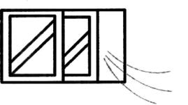
should be disposed off as indicated by the local authorities.
The equipment must not be installed within explosive
amblence, In the open air or exposed to rain the correct
≥50cm
siting is; distant from direct sources ( radiators, direct

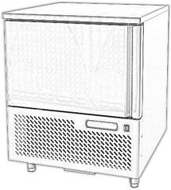
lighting, etc...) and protected from direct sunlight and
draughts. Air circulation must be freely maintained
around the condensing unit, be it integral or remote.
In observance of these specific conditions will
detrimentally affect the cabinet.s.

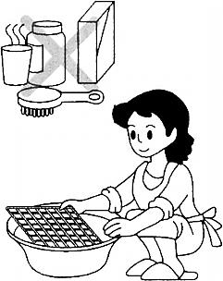
INITIAL CLEANING

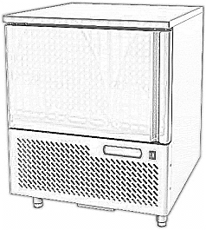
Before use all parts of the cabinet should be cleaned,
For the walls and all the internal parts use an
antibacterial detergent. For the plastic parts use a
moistened cloth.Dry with a soft clean cloth.use
little or no water.
Do not use harsh or abrasive solvents or detergents
During cleaning do not approach bare-handed those
parts which could cut (evaporator, condenser, etc.) and always use protective gloves.

Electrical connection
Grounding Terminal
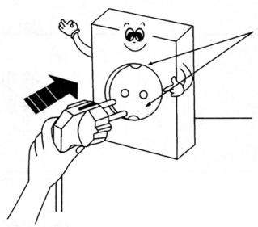
Check that the supply conforms to the requirements
listed on the factory label and that it is provided
with a fall-safe protection or automatic circuit
AC220-240V
Outlet Only
breaker with an efficient earth connection.
Should there not be an electrical safety
feature have this introduced by a qualified person.
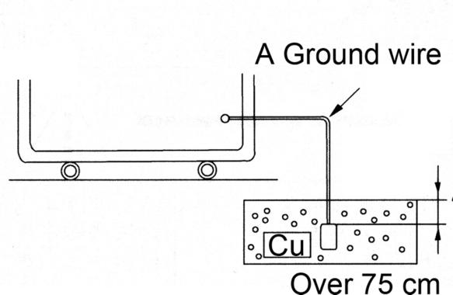
by means of a omnipolar switch as indicated
in the safety regulations with a means of a
omnipolar switch as indicated in the safety
regulations with a minimum clearance of the
contacts of 3 mm. where the cabinet
has to be installed at some distance from
the electrical source.ensure that the conforms
to the local regulations. Cabinet supplled
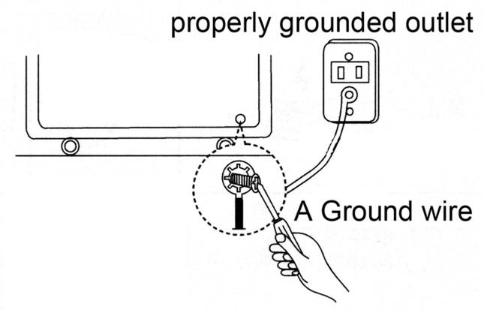
with integral condensing units are provided
with an appropriate plug fitted with a neutral
and earth; the supply cable must be well
stretched (avoid coilling and superimposition).
it must not be exposed to the possibility of damage
by third parties. it should not be in contact with
liquids, water or heat sources. in the event
of damage it must be replaced by qualified
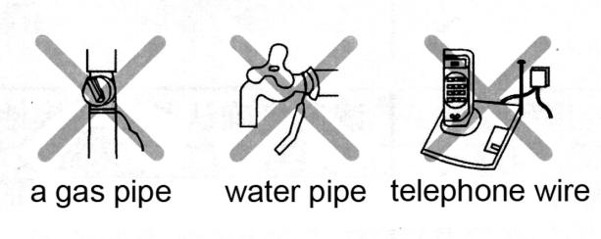
personnel. Always avoid the use of reducers or adapters.

CONNECTION TO DRAINS
The dispersal of defrost water is automatic in all models with integral condensing unit.

- TECHNICAL CHARACTERISTICS
  - NOISE AND VIBRATION
The sound level of the equipment fitted with integral hermetic condensing unit does not exceed 70 dB,it is therefore not necessary to provide sound insulation. Under normal conditions the equipment does not generate vibrations which affect surroundings.
  - POSSIBLE USAGES
Do not utilise the equipment to store medical supplies. the optimum operational ambient temperatures are between +10℃/ +32℃

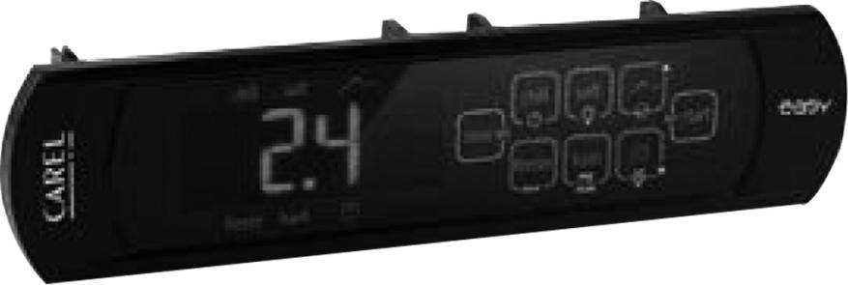
- USAGE FOR CAREL
  - ACTION
These devices are activated by one switches and an electronic control panel.
  - Meaning of the button
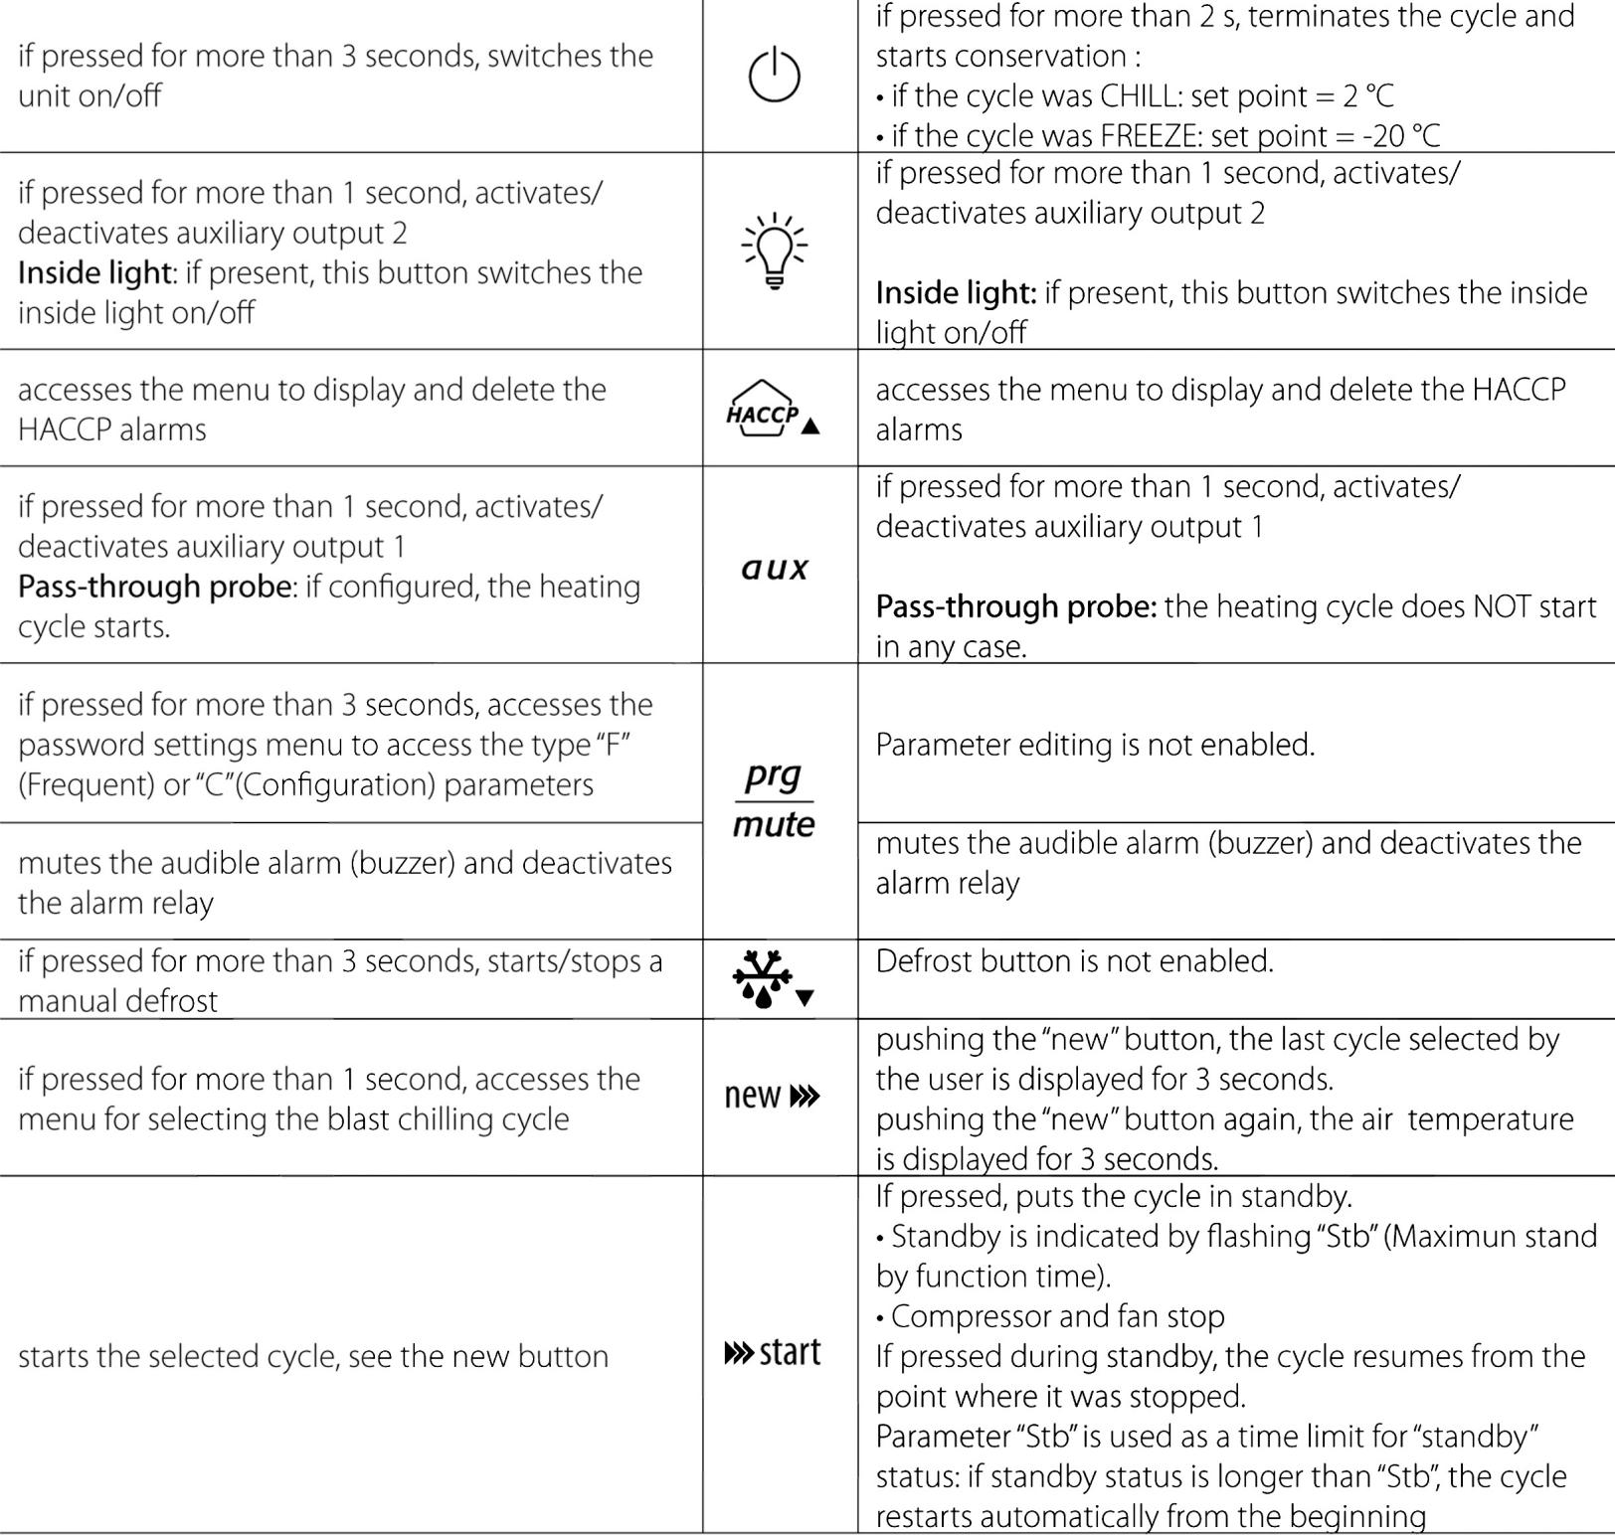
  - Selecting the BLAST CHILLING cycle
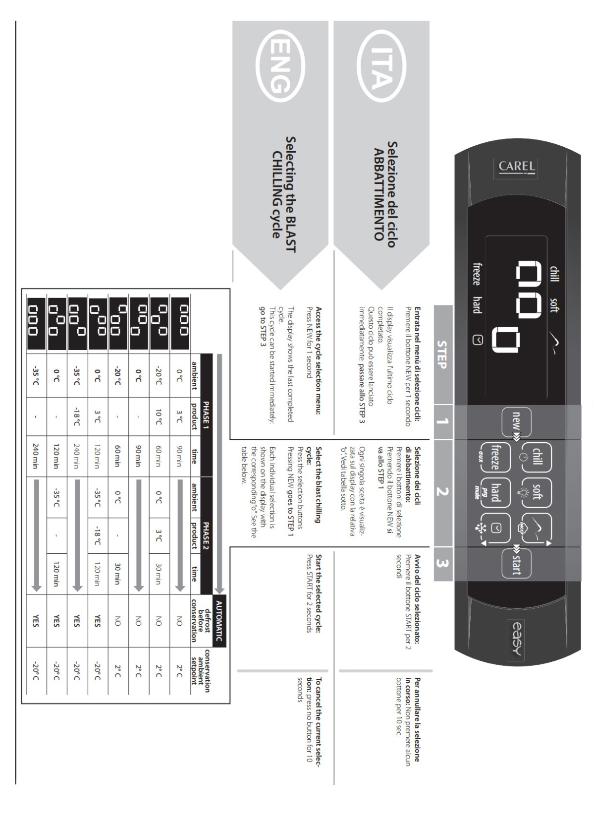
  - How to access and set parameters
type “F” (FREQUENT, not protected by password), type “C” (CONFIGURATION, password protected)
Step | Action | Effect | Meaning
1 | Press PRG for 3 seconds | After 3 seconds the display will show the 1st parameter, “0”(Password) | Access to type ”F” parameters is direct without password
2 | Press UP or DOWN | The value on the display will increase or decrease. | Enter the password ”22” to access the type “C” parameters or whatever different value for the type “F” parameters.
3 | Press START | The display will show “St” (Setpoint) | This is the current value of the Setpoint
4 | Press UP or DOWN | If the password set is 22 the display will scroll the list of type “C” parameters(CONFIGURATION) otherwise the list of type ”F” parameters(FREQUENT) | Set the desired value
5 | Press START | The display will show the parameter name | This is the current value of the parameter
6 | Press UP or DOWN | The value on the display will increase or decrease | Set the desire value
7 | Press START | The display will show the parameter name again | IMPORTANT: parameters not yet saved
8 | Repeat steps 2,3,4&5 for all parameters required
9 | Press PRG for 5 seconds | The controller will display the temperature read by the probes again | IMPORTANT: only now have all the parameters been updated
For both types of access (type “F” and type “C”) there is a timeout (no button on the keypad pressed for 1 min), the procedure is ended without saving the parameter.
  - Accessing the parameters divided by functional blocks
Once having accessed the type “F” or “C” parameters (see tables above)
Step | Action | Effect | Meaning
1 | Press PRG | The display will show the name of the functional block that the parameter belongs to | Example ‘CMP’ for the compressor parameters, ‘dEF’ for the defrost parameters
2 | Press UP or DOWN | The display will show the name of the other functional blocks | Example ‘Fan’ for the fan parameters
3 | Press START | The display will show the name of the first parameter in the functional block selected | Example “F0” for ‘Fan’
  - Directly accessing the parameters by selecting the category
The configuration parameters can also be accessed, in addition to the mode described above, via the category (see the icons and abbreviations inthe table below), according to the list on the display with the corresponding name and icon. To directly access the list of parameters grouped bycategory, press the PRG button for at least 1 second and to modify the parameter press DOWN+ START + UP.
Category | Paraneters | Message | Icon
Probe parameters | / | ‘pro’ | 
Control parameters | r | ‘Ctl’ | 
Compressor parameters | c | ‘CMP’ | 
Defrost parameters | d | ‘dEF’ | 
Alarm parameters | A | ‘ALM’ | 
Fan parameters | F | ‘FAn’ | 
Configure parameters | H configuration | ‘CnF’ | 
HACCP parameters | H HACCP | ‘HcP’ | 
RTC parameters | rtc | ‘rtc’ | 
  - Alarms with manual reset
The alarms with manual reset can be reset by pressing the PRG and UP for more than 3 s.
  - HACCP function
ir33+ is compliant with the HACCP standards in force since it allows the monitoring of the temperature of the stored food.
“HA” alarm = exceeded maximum threshold: up to three HA events are saved (HA, HA1, HA2) respectively from the more recent (HA) to the oldest (HA2) and a HAn signal that displays the number of occurred HA events.
“HF” alarm = power failure lasting over a minute and exceeded AH maximum threshold: up to three HF events are saved (HF, HF1, HF2) respectively from the more recent (HF) to the oldest (HF2) and a HFn signal that displays the number of occurred HF events. HA/HF alarm setting: AH parameter (high temp. threshold); Ad and Htd (Ad+Htd = HACCP alarm activation delay).
Display of the details: access to HA or HF parameters pressing the START button and use UPor DOWN buttons to glance over. HACCP alarm erasing: press the DOWN and SET buttons for more than 5 seconds, the message ‘res’ indicates that the alarm have been deleted. To cancel the saved alarms press the DOWN+ START + UP buttons for more than 5 seconds.
  - Procedure for setting the default parameter values
To set the default parameter values on the controller, proceed as follows:
• If “Hdn” = 0:
1: switch the instrument off;
2: switch the instrument back on, holding the PRG button until the message “Std” is shown on the display.
Note: the default values are only set for the visible parameters (C and F). For further details see table “Summary of operating parameters”.
• If “Hdn” < > 0:
1: switch the instrument off;
2: switch the instrument back on, holding the PRG button until the value bn0 is shown on the display;
3: select the set of default parameters, between 0 and “Hdn”, using the DOWN and UP buttons;
4: press the START button until the message “Std” is shown on the display.
- USAGE FOR DIXELL

  - QUICK REFERENCE GUIDE
7.1.1 KEYBOARD
 | Display target set point outside programing mode. In programing mode, it selects a parameter or confirm an operation. pushing the key to set the Hds
 | (UP) Start or stop a manual defrost. Short time pushing and releases to see the max . stored room temperature. In programing mode, it browses the parameter codes or increases the displayed value.
 | Short time pushing and releases to choose Hard cycle
 | (DOWN)After cycle selected and before cycle starting push the key above 3S the cycle will switch from time mode and temperature mode. In programing mode, it browses the parameter codes or decreases the displayed value. Keeping the key until showing the remain time of current phase if the cycle of timer mode starts (show Phase : PH1, PH2 … 1S then show time)
 | Push and release the key to start or pause the chiller cycle  switch the instrument on/off (Push the key above 3S) if onF=oF.
 | Push and release the key to switch the light
 | To choose the chiller cycle or freeze cycle. push the key until the first parameter (cyS) appears to set the cycle parameter. hold pushed more than 2 seconds to stop the chiller cycle
 | Push and release the key to switch the AUX  Push the key above 2S to see the probe temperature

7.1.2 KEY COMBINATIONS
+ | The keyboard unlocks or lock combination; the lock does not allow editing the parameters while the instrument functions are still active.
+ | Enter in programming mode
+ | Return to room temperature display
+ | Show the current phase (Show PH1, PH2, …)

7.1.3 MEANING OF THE LEDS
LED |  | MODE | Function
 |  | ON | Compressor enabled
 |  | Flashing | Anti-short cycle delay enabled (Refer to “Ac” parameter)
 |  | ON | Defrost enabled
 |  | Flashing | Drip time in progress
 |  | ON | Fan enabled
 |  | Flashing | Fan delay after defrosting in progress
 |  | ON | An alarm is occurring
CH |  | ON | Chiller cycle is working
CH |  | Flashing | Chiller cycle
FR |  | ON | Freeze cycle is working
FR |  | Flashing | Freeze cycle
HD |  | ON | Hard mode
HD |  | OFF | Soft mode
LED |  | MODE | Function
℃/℉ |  | ON | Measurement unit
℃/℉ |  | Flashing | Programming phase
 |  | ON/ Flashing | The cycle is defined by time or remain time of current phase
 |  | ON/ Flashing | The cycle is defined by temperature
HACCP |  | ON | Display is showing max . stored or Min. stored room temperature
 |  | Flashing | hold phase
 |  | ON | Instrument is Off
 |  | OFF | Instrument is On
  - CHILLING\ FREEZING CYCLES
    - HOW TO EDIT THE PARAMETERS OF A CHILLING/FREEZING CYCLE
Cycle programming is only possible with the instrument in stand-by (no cycles active).
- Select the cycle.
The icons identify the cycles with the following correspondence:
CH | Soft Chilling
FR | Soft Freezing
HD + CH | Hard Chilling
HD + FR | Hard Freezing
- Keep the key pressed above 3 seconds until the display shows the label of the first parameter (CYS) of the selected cycle
- Select the desired parameter with the keys
- Press the key
- Edit it with the and keys .
- Press to store the new value and move to the code of the following parameter.
- Press + or wait 15sec without pressing any key to exit.

    - SHORTCUT MODIFICATION THE TEMPERATURE AND TIME MODE OF CYCLE
Push thekey above 3S the cycle will switch from time mode and temperature mode before cycle starts
At the temperature cycle, the display shows stop set point probe of last phase (probe depends on the “rEm”) At the time cycle, the display shows the total time of cycle. After starting time mode shows the remaining total of time. Temperature mode shows the real -time temperature of set point probe. Before any cycle starting or in the conservation shows the room probe temperature.
    - VIEW PROB TEMPERATURE
- Push the key above 2S into view probe temperature mode;
- Choose the probe label by
- Push the key to confirm then show the temperature;
- Push the again to back to label chosen (item 2) and show next probe label;
- After no action about 5s or pushing + to exit;

- MANITENANCE
  - PERIODIC CLEANING
For hygienic reasons and improved performance clean at least once a month the internal basin. Especially the hole for water out going, need keep clean always, First perform a manual defrosting cycle ( par. 6.3 ),
When complete, switch off the power supply and clean the inside following the instructions given in par. 4.2 ( initial cleaning ).
  - CLEANING OF CONDENSER
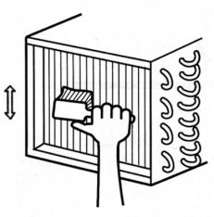
For improved performance clean the condenser at least once a week.
Before beginning turn off the equipment, and disconnect the plug.
Close and protect the unit.
- Unscrew, rotate and remove protective grill
- Remove the dust deposited on the front surface of the condenser
using a brush and a vacuum cleaner and restore previous conditions.
  - PERIOD OF INACTIVITY OF CABINET
During periods of inactivity, remove the products from thecabinet and then follow these directions:
- Remove the plug out from the outlet and carefully clean the unit
as per periodic cleaning
- Cover the cabinet whit a cloth that allows air circulation in the interior.
- TROUBLE SHOOTING AND REMEDIES
Often, the malfunction of a unit is due to simple causes which can easily be eliminated without contacting a technician.Therefore execute the following controls
  - If the cabinet does not operate, make sure that:
- The plug has been correctly inserted into the socket.
- The supply cord is not damaged.
  - If the required temperature is not achieved, make sure that;
- The command switch is turned on.
- The electronic control panel is correctly regulated (see 6.1.3, 6.1.4).
- The cabinet is neither in the defrosting phase nor in the
post-defrosting pase.
- The evaporator is not covered with frost (see 6.3).
- The condenser is not blocked with dust.
- The cabinet is not located near heat sources or its condensing unit
has uninterrupted air flow.
- The stored foods or other objects do not inhibit proper closing of the unit.
- The cabinet is not working in anomalous conditions (overloaded, loaded with hot food, or loaded in a way that prevents proper air circulation).
  - If the cabinet leaks water, make that:
- The collecting container or the device for condensing water elimination are not damaged.
- The discharge outlets are not blocked or obstructed.
- The cabinet has been properly leveled.
  - If the cabinet is unacceptably noisy, make sure that:
- The frame does not have loose screws or bolts.
- The cabinet has been laid in a stable position and correctly leveled.
If, after all these controls, the malfunctioning continues, it is advisable to contact technical assistance. Be prepared to supply the following information:
- The model trade name and the serial number (both can be found on the technical data plate ).
- The alarm codes appearing on the display of the control panel.
  - IMPROBABLE RISKS
In case of fire unplug the cabinet, if possible, and use a powder fire extinguisher.

- SUBSTITUTION OF SPARES
Before commencing any service or maintenance work, isolate the cabinet from the electrical supply.
Always fit original spares which may be obtained from an authorized concessionaire or stockist.

- DISMANTLING
The scrapping of the cabinet requires to be undertaken by specialized company, licensed by the local authorities, and observing local statutes.Polyurethane foaming material, not fire-resistant, when deal with the material, should be according with local law and statue.
- The cabinet consists of:
- Structure in steel plate,
- Electrical components and cables,
- Electrical compressor.
- Plastic materials,
- Refrigerant fluid which must not be discharged into the atmosphere.
ALL THE RESPONSIBILITY FOR THE FAILURE TO RESPECT THE EXISTING LOCAL STATUTES ARE THE RESPONSIBILITY OF THE OWER.
Meaning of crossed –out wheeled dustbin:
Do not dispose of electrical appliances as unsorted municipal waste, use separate collection facilities. Contact you local government for information regarding the collection systems available. If electrical appliances are disposed of in landfills or dumps, hazardous substances can leak into the groundwater and get into the food chain, damaging your health and well
-being. When replacing old appliances with new ones, the retailer is legally obligated to take back your old appliance for disposals at least free of charge

Technical Parameters
Model | EBF-03 | EBF-05 | EBF-10 | EBF-15
Fast cooling performance per cycle/kg | 10Kg(+90℃/+3℃) in 90 Min | 25Kg(+90℃/+3℃) in 90 Min | 50Kg(+90℃/+3℃) in 90 Min | 75Kg(+90℃/+3℃) in 90 Min
Fast freezing performance per cycle/kg | 5Kg(+90℃/-18℃) in 240 Min | 15Kg(+90℃/-18℃) in 240 Min | 30Kg(+90℃/-18℃) in 240 Min | 45Kg(+90℃/-18℃) in 240 Min
Rated voltage | 220-240V,50Hz | 220-240V,50Hz | 220-240V,50Hz | 220-240V,50Hz
Rated power(W) | 1100 | 1300 | 2500 | 3600
Current(A) | 6 | 6.5 | 12 | 18
Auxiliary heater | 13 | 13 | 20 | 30
Safety climate class | 4 | 4 | 4 | 4
Room temperature | 30℃ | 30℃ | 30℃ | 30℃
Relative humidity | 55% | 55% | 55% | 55%
Volume(L) | - | - | - | -
Refrigerant | R290 | R290 | R290 | R290
Amount(g) | 150 | 150 | 150*2 | 150*2
Dimension D×W×H(mm) | 755×832×581 | 750×815×870 | 750×830×1435 | 750×830×1860
Inner fitting | 3 trays GN1/1 - 3 trays EN 600×400 | 5 trays GN1/1 - 5 trays EN 600×400 | 10 trays GN1/1 - 10 trays EN 600×400 | 15 trays GN1/1 - 15 trays EN 600×400
Condensation | air | air | air | air

Energy efficiency parameters
Model(s): |  | EBF-03
Type of product |  | Blast chiller / Blast freezer
Refrigerant fluid(s): |  | R290 (Propane), GWP: 3
Indication of the program used for blast chilling
Indication of the program used for blast freezing
Item |  |  | Symbol | Value | Unit
Energy consumption for chilling function |  |  | E | 0,1218 | kWh /kg
Chilled full load capacity |  |  |  | 10,00 | kg
Energy consumption for freezing function |  |  | E | 0,7842 | kWh /kg
Frozen full load capacity |  |  |  | 5,00 | kg
Refrigerant charge |  |  |  | 0,15 | kg
Blast chilling cycle from + 65°C to + 10°C |  |  | t | 90 | min
Blast freezing cycle from + 65°C to - 18°C |  |  | t | 270 | min
Contact details | Yindu Kitchen Equipment Co., Ltd.  No. 1 Xingxing Road, Xingqiao District, Yuhang, Hangzhou, Zhejiang 311100, China

Model(s): |  | EBF-05
Type of product |  | Blast chiller / Blast freezer
Refrigerant fluid(s): |  | R290 (Propane), GWP: 3
Indication of the program used for blast chilling
Indication of the program used for blast freezing
Item |  |  | Symbol | Value | Unit
Energy consumption for chilling function |  |  | E | 0,0576 | kWh /kg
Chilled full load capacity |  |  |  | 25,00 | kg
Energy consumption for freezing function |  |  | E | 0,2804 | kWh /kg
Frozen full load capacity |  |  |  | 15,00 | kg
Refrigerant charge |  |  |  | 0,15 | kg
Blast chilling cycle from + 65°C to + 10°C |  |  | t | 72 | min
Blast freezing cycle from + 65°C to - 18°C |  |  | t | 240 | min
Contact details | Yindu Kitchen Equipment Co., Ltd.  No. 1 Xingxing Road, Xingqiao District, Yuhang, Hangzhou, Zhejiang 311100, China
Model(s): |  | EBF-10
Type of product |  | Blast chiller / Blast freezer
Refrigerant fluid(s): |  | R290 (Propane), GWP: 3
Indication of the program used for blast chilling
Indication of the program used for blast freezing
Item |  |  | Symbol | Value | Unit
Energy consumption for chilling function |  |  | E | 0,042 | kWh /kg
Chilled full load capacity |  |  |  | 50,00 | kg
Energy consumption for freezing function |  |  | E | 0,16 | kWh /kg
Frozen full load capacity |  |  |  | 30,00 | kg
Refrigerant charge |  |  |  | 0,15*2 | kg
Blast chilling cycle from + 65°C to + 10°C |  |  | t | 65 | min
Blast freezing cycle from + 65°C to - 18°C |  |  | t | 210 | min
Contact details | Yindu Kitchen Equipment Co., Ltd.  No. 1 Xingxing Road, Xingqiao District, Yuhang, Hangzhou, Zhejiang 311100, China
Model(s): |  | EBF-15
Type of product |  | Blast chiller / Blast freezer
Refrigerant fluid(s): |  | R290 (Propane), GWP: 3
Indication of the program used for blast chilling
Indication of the program used for blast freezing
Item |  |  | Symbol | Value | Unit
Energy consumption for chilling function |  |  | E | 0,089 | kWh /kg
Chilled full load capacity |  |  |  | 45,00 | kg
Energy consumption for freezing function |  |  | E | 0,0326 | kWh /kg
Frozen full load capacity |  |  |  | 75,00 | kg
Refrigerant charge |  |  |  | 0,15*2 | kg
Blast chilling cycle from + 65°C to + 10°C |  |  | t | 40 | min
Blast freezing cycle from + 65°C to - 18°C |  |  | t | 200 | min
Contact details | Yindu Kitchen Equipment Co., Ltd.  No. 1 Xingxing Road, Xingqiao District, Yuhang, Hangzhou, Zhejiang 311100, China

OFFICIAL APPROVAL AND RULES
Our products full fill the present E.U. rules, including the CE mark of the European official approval
Machinery Directive (MD) 2006/42/EC
Electromagnetic Compatibility (EMC) Directive 2014/30/EU
EN 60335-1 EN 55014-1
EN 60335-2-89 EN 55014-2
EN 62233 EN 61000-3-2
EN 61000-3-3

Serial № C003-106-076

Summary of operating parameters

Signals on the display

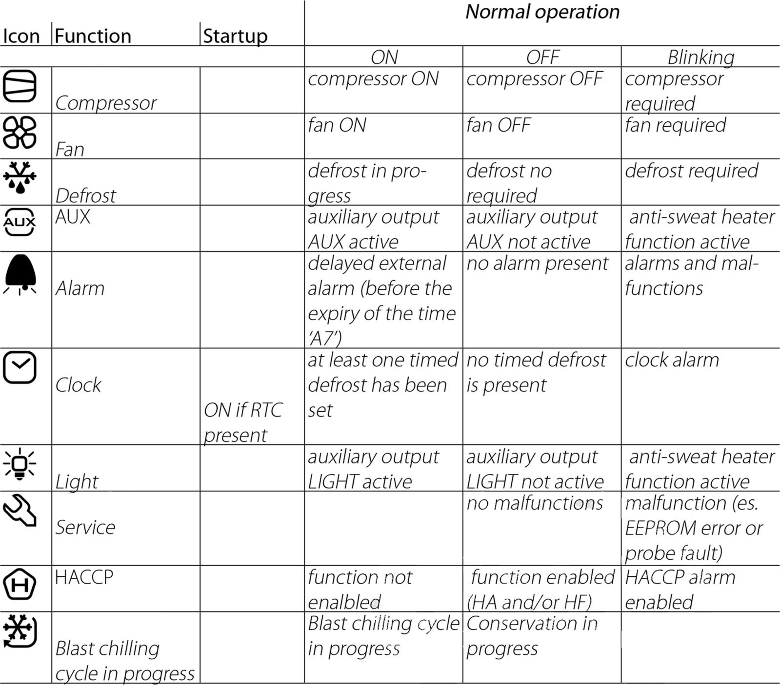

CORRECT DISPOSAL OF THIS PRODUCT
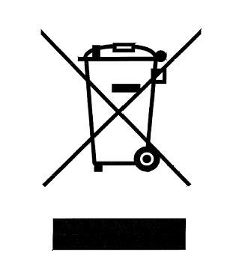
This marking indicates that this product should not be disposed with other household wastes throughout the EU. To prevent possible harm to the environment or human health from uncontrolled waste disposal, recycle it responsibly to promote the sustainable reuse of material resources. To return your used device, please use the return and collection systems or contact the retailer where the product was purchased. They can take this product for environmental safe recycling.

R10001000403（W081125401）@20230412

