Warm Tips:

Please read the manual carefully before using the product.

**Operation Instruction for Display Cabinet**

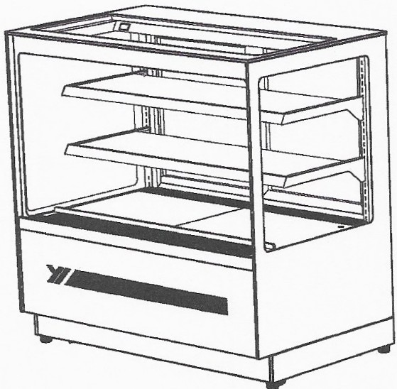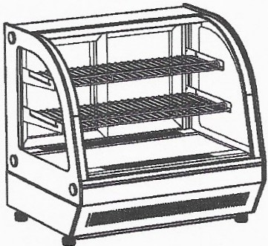

□WDF series □WT series

Contents

Precaution 1

Transportation and handling 2

Installation and operation 2

Maintenance 3

Troubleshooting 4

Structure diagram 5

Circuit diagram 6

Setting of the digital controller 7

Major technical parameters 8

Disposal of the product. 12

Warranty Information 13

## Precaution

1. Please read the manual carefully before using the cabinet. For any doubt, please contact our company.
2. This series of products are mainly applicable to refrigeration and display cakes and relevant food. During normal operation, the temperature inside the cabinet is 0~8°C(for WDFseries) or 2,.. ,8°C(for LK series). Do not use this equipment for other purposes in case of serious accidents.
3. The equipment is suitable to be placed in supermarket, cake store and hotels.
4. The equipment shall be put at dry place with good ventilation. Don't put it near any heat source or dust. Don't place it directly under the sunshine.
5. Put the equipment on a flat and solid place. The distance from the wall or other objects shall not be less than 20cm.
6. It is a kind of electrical equipment. Please pay attention to the safety.
   * Independently single-phase three-pole socket shall be used. The earth wire port (E) of the socket shall be reliably grounded.
   * The power supply shall be 220 ,, 240V/50Hz. Otherwise, power supply stabilizer with capacity matching with the equipment power shall be installed to ensure smooth operation of the equipment.
   * The power cord of the equipment shall not be directly placed in the aisle. Avoid heavy weight and sharp objects.
   * Do not operate the equipment with wet or naked hand or foot.
   * Please cut off the power supply if the equipment is not to be used for long time.
   * Please cut off the power supply before installation or dismantling the parts.
   * Never flush the equipment directly with water; otherwise the parts will get wet and current leakage might be resulted.
   * In case of electrical or refrigeration failure, service agent authorized by the manufacturer or professional maintenance staff shall be responsible for the maintenance work in case of danger or expanded failure.
7. Do not store explosive substances such as aerosol cans with a flammable propellant inside the appliance.
8. WARNING - Keep clear of obstruction all ventilation openings in the appliance enclosure or in the structure for building-in.
9. WARNING - Do not use mechanical devices or other means to accelerate the defrosting process, other than those recommended by the manufacturer.
10. WARNING - Do not damage the refrigerant circuit.

###### 1

1. WARNING - Do not use electrical appliances inside the food storage compartments of the appliance, unless they are of the type recommended by the manufacturer.
2. Please according to local regulations regarding disposal of the appliance for its flammable blowing gas. Before you scrap the appliance, please take off the doors to prevent children trapped.
3. If the supply cord is damaged, it must be replaced by the manufacturer or its service agent or a similarly qualified person in order to avoid a hazard.
4. The maximum loading of every shelf is 30kg(for WDF series) or 10kg(for LK series).
5. Climate class 3 means 25°C,RH60%.
6. This appliance can be used by children aged from 8 years old and above and persons with reduced physical, sensory or mental capabilities or lack of experience and knowledge if they have been given supervision or instruction concerning use of the appliance in a safe way and understand the hazards involved.
7. Children shall not play with the appliance.
8. Cleaning and user maintenance shall not be made by children without supervision.

### Transportation and handling

1. Special package box will be used for the equipment for delivery. Keep the equipment erect during transportation and handling.
2. Please carefully check the package box after receiving the product to ensure that the equipment is not damaged during transportation.
3. When removing the package box, carefully move away the wood plate in case of scratch the equipment.
4. In case that the equipment tilts during the transportation and handling, the lubricant in the compressor may flow into the cooling loop. Therefore, in order to ensure the lubricant flows back to the compressor, it is necessary to keep the equipment erect for 24 hours before it starts to work.
5. Do not throw away the package removed randomly. Please dispose as per relevant local rules and regulations.

### Installation and operation

1. After the equipment is installed, please carefully clean parts in the cabinet .Then wipe clean the bottom cover plate and shelf, put them on corresponding place, close the cabinet door and get it connected to the

2

power supply.

1. Turn on the lighting switch, check light on each shelf is normal.
2. The controller is delivered with default parameters. Do not alter the parameters casually except for special need.
3. When running for the first time, it should run without load for 2 hours to ensure the refrigeration system is working normally. Only when the temperature within the cabinet is reduced within the indicated scope can the food be put into the cabinet.
4. Don't put too much over-hot food in the cabinet to prevent instantaneous high load. The food shall not block the air outlet and air inlet. Nor shall it be close to side glass. Otherwise it will lead to condensation.
5. To save electricity, the heating wire switch is defaulted to be closed. If the environment humidity is large, and there is condensation on the front glass, please open it for defogging.
6. To keep the taste of the food, please have the equipment running 24 hours a day.
7. During the frosting process, the temperature of the cabinet may rise slightly.

When the frosting end, it will return to normal .

## Maintenance

1. In order to ensure food health and quality, please ensure to that the equipment is cleaned frequently.
2. Before cleaning, plug off the power supply.
3. Use neutral detergent and mild water to clean the cabinet. To get rid of the residual of the detergent, please use clean cloth to wipe repeatedly.
4. Clean the dust and sundries on the condenser regularly on monthly basis. Take off the dustproof hood, flush the filtration mesh with clean water and then put it back after being dried-out.
5. Do not use any organize solvent (gasoline or alcohol etc.) to clean the equipment. Parts inside the equipment may be damaged. Besides, explosive gas may be generated.
6. Wet towel may be used to wipe the equipment surface. However, do not have it contact with water directly.
7. After cleaning the equipment, please ensure it is completely dried before using.

3

### Troubleshooting

|  |  |  |
| --- | --- | --- |
| Troubles | Causes | Solutions |
| No power  supply input | Poor socket contact | Repair or replace the socket |
| Input control wire failure | Repair the failure point |
| High cabinet temperature | Near a heat source | Move the counter or the heat source |
| Frost block | Defrost manually |
| Over-inventory in the  cabinet which blocks the air outlet and inlet | Take out part of the goods,  move them away from the air outlet and inlet |
| Refrigerant leaking | Check the leak and refill  refrigerant |
| Condenser contaminated | Clean the dust-hood |
| Fan failure | Repair or replace the fan |
| Temperature controller failure | Replace the temperature controller |
| Temperature control probe  touch the bottom | Replace the position of  temperature control probe |
| Too much noise | The product is not put smoothly | Adjust the feet |
| The set screws of fans or  compressor are loose | Tighten the screws |
| The compressor is not running | The voltage is beyond the permitted range | Use a voltage regulator.and connect with the appropriate power supply |
| Temperature controller failure | Replace the temperature controller |
| The compressor damage | Replace the compressor |
| The light failure | Switch off or failure | Turn on the switch |
| Wire connection is not  reliable | Check the plug point |
| The light power supply  damaged | Replace the light power supply |
| light damaged | Replace the light |

Note:

1. For simple troubleshooting, please be sure to disconnect the power supply.
2. For the maintenance and replacement work, please call for professionals or the maintenance staff from the refrigeration factory of the manufacturer.
3. If the above methods could not solve the problem, please call for professionals.

4

## Structure diagram

**WDF series GLASSES**

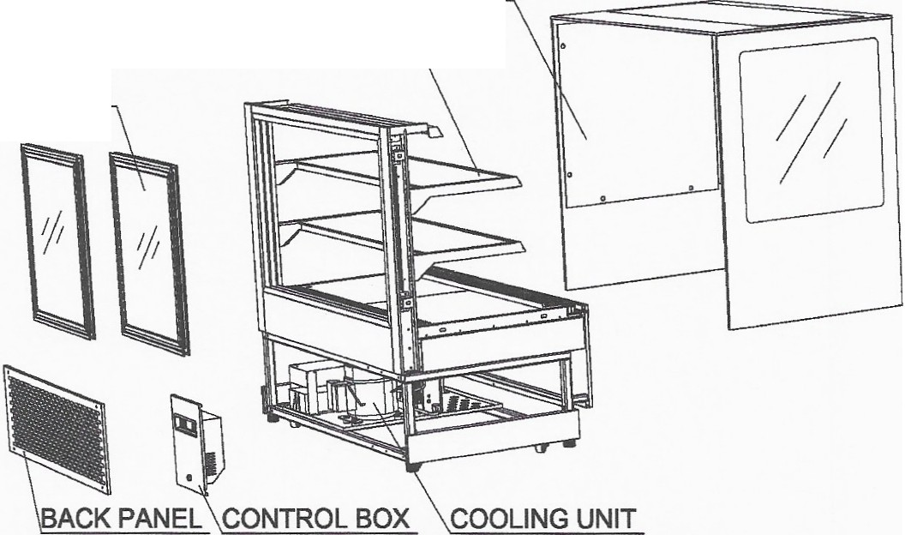

**SHELF**

**DOOR**

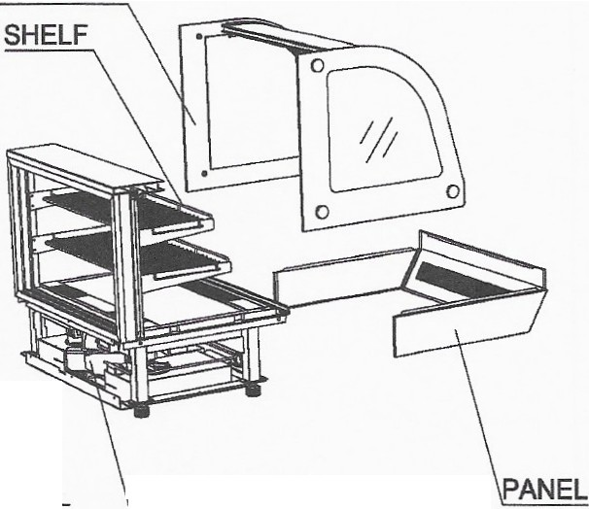**LK series GLASSES**

**DOOR**

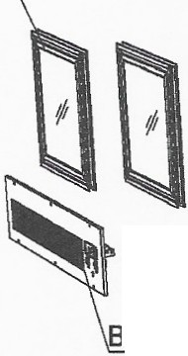**ACK PANEL COOLING UNIT**

Note: refer to the real object in case of change of the product structure.

5

# Circuit diagram

**for WDF series**

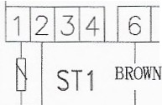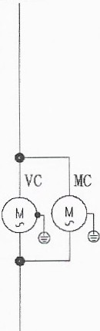

**D**

7 8 9

BROWN BLUE BROWN

BROWN

VE

SWl

BLUE

BWE

|  |  |  |  |  |  |
| --- | --- | --- | --- | --- | --- |
| DK | TRANSFORMER |  | SWl | COMPRESSOR SWITCH |  |
| MC | COMPRESSOR |  | SW2 | LIGHT SWITCH |  |
| TR | SWITCHPOWER SUPPLY | 24V | SW3 | DEFOG SWITCH |  |
| 1A | STRIP LIGHT |  | RSI | HEATING**WIRE** | FRONT GLASS |
| VE | EVAPORATOR FAN MOTOR | | RS2 | HEATING WIRE | DOORFRM!E |
| D | MICROCOMPUTER CONTROLLER | XR02C | VG | CONDENSER FAN MOTOR |  |
| STl | ROOM PROBLE |  |
| CODE | NAME | REMAR | KCODE | NAME | REMARK |

**L** --BROWN

**for LK series**

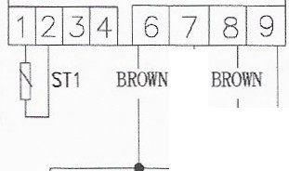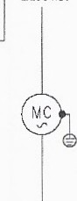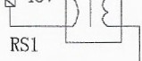

RS2

NOTE:

36V:\VDF127F

WDF157F 48V:IVDFl77F

24V:OTHERS

I

- YELLOW & GREEN

•

TR

**E**

SW2 *(*

•I

SIV3

BROWN

BROWN

AC220~240V

N--BWE

BLUE

BLUE

|  |  |  |  |  |  |
| --- | --- | --- | --- | --- | --- |
| S1 | LIGHT SWITCH |  | STl | ROOM PROBLE |  |
| F | EMI FILTER |  | Tb | TEMINAL BLOCKS |  |
| DCl2\ | SWITCH POWER SUPPLY | 12V | Ml | FAN for EVAP. &COND. |  |
| L | LED LIGHT |  | Al2 | FAN for EVAP.&COND. |  |
| S2 | COMPRESSOR SWITCH |  | MC | COMPRESSOR |  |
| D | MICROCO)!PUTER CO'.'ITROLLER | XR02CX |  |  |  |
| CODE | NAME | REl!ARI | CODE | NAME | REMARK |

**D**

**L**  BROWN , �

j

A�22~0_2_40_v_ BLUE BRO��

BROll"l

BLUE BROWN

E� SI �L

-

YELLOW & GREEN BLUE

�

� BLUE

BLUE

Note: the part in dotted line box is not applicable to some types. Please refer to the real object for the wiring circuit.

6

### Setting of the digital controller

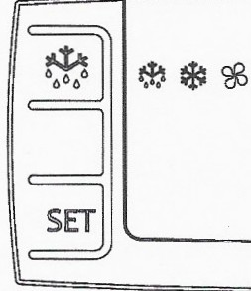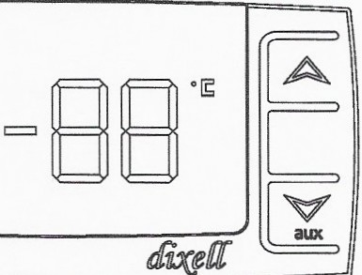

1. Refer to the digital controller operating manual to see how to use the controller.
2. The setting values for the products as follows:

|  |  |  |  |
| --- | --- | --- | --- |
| lABlE | DESCRIPTION | VAlUSE | |
| WDF series | WT series |
| SET | Set Point | 2°C | 2·c |
| Hy | Differential | 3•c | 3•c |
| od | Output action delay at start up | 1mi n | 1min |
| AC | Anti-short cycle delay | 5min | 4min |
| CH | Kind of action | cl | cl |
| rE | Resolution (onIy for ·c) | in | in |
| id | Interval between def. cycles | 6h | 3h |
| Md | Max Iength for def. | 15min | 15min |

7

# Major technical parameters

1. These products are designed with climate type 3;

|  |  |  |  |  |  |  |
| --- | --- | --- | --- | --- | --- | --- |
| Model | storage temperature  (°C) | Power supply | Input power  **(W)** | Refr igeran t | Volume  (L) | Size LXWXH  (mm) |
| Right-angle Display Case | | | | | | |
| WDF097F | 0~8 | 220~24ov  50/60Hz | 510 | R290 | 311 | 900X750X1200 |
| WDF127F | 700 | 421 | 1200X 750X 1200 |
| WDF157F | 800 | 532 | 1500X 750X 1200 |
| WDF177F | 900 | 608 | 1700 X 750X 1200 |
| Single Arc Display Case | | | | | | |
| WDF097D | 0~8 | 220~24ov  50/60Hz | 510 | R290 | 306 | 900X 750X 1350 |
| WDF127D | 700 | 410 | 1200X 750X 1350 |
| WDF157D | 800 | 518 | 1500 X 750X 1350 |
| WDF177D | 900 | 602 | 1700X 750X 1350 |
| Obi ique-angle Display Case | | | | | | |
| WDF097X | 0~8 | 220~24ov  50/60Hz | 510 | R290 | 269 | 900X 750X 1200 |
| WDF127X | 700 | 364 | 1200X 750X 1200 |
| WDF157X | 800 | 461 | 1500X 750X 1200 |
| WDF177X | 900 | 526 | 1700X 750X 1200 |
| Double-arc Display Case | | | | | | |
| WDF097S | 0~8 | 220~24ov  50/60Hz | 510 | R290 | 323 | 900X750X1350 |
| WDF127S | 700 | 438 | 1200X 750X 1350 |
| WDF157S | 800 | 554 | 1500 X 750X 1350 |
| WDF177S | 900 | 630 | 1700X 750X 1350 |
| Double-arc Display Case | | | | | | |
| WDF097Z | 0~8 | 220~24ov  50/60Hz | 510 | R290 | 373 | 900X750X 1350 |
| WDF127Z | 700 | 505 | 1200X 750X 1350 |
| WDF157Z | 800 | 638 | 1500X 750X 1350 |
| WDF177Z | 900 | 730 | 1700X 750X 1350 |
| Square-Countertop Display Case | | | | | | |
| WTF120L | 2~8 | 220~24ov  50/60Hz | 242 | R290 | 120 | 700X 560X 670 |
| WTF160L | 160 | 900X 560X 670 |
| Curved-Countertop Display Case | | | | | | |
| WTY110L | 2~3 | 220~24ov  50/60Hz | 242 | R290 | 110 | 700X 560X 670 |
| WTY130L | 130 | 900X 560X 670 |

**8**

|  |  |  |  |  |  |  |
| --- | --- | --- | --- | --- | --- | --- |
| Right-angle Display Case | | | | | | |
| WDF097F | 0~8 | 220~24ov  50/60Hz | 510 | R134a | 311 | 900X 750X 1200 |
| WDF127F | 700 | 421 | 1200X750X1200 |
| WDF157F | 800 | 532 | 1500 X 750X 1200 |
| WDF177F | 900 | 608 | 1700 X 750X 1200 |
| Single Arc Display Case | | | | | | |
| WDF097D | 0~8 | 220~24ov  50/60Hz | 510 | R134a | 306 | 900X 750X 1350 |
| WDF127D | 700 | 410 | 1200X 750X 1350 |
| WDF157D | 800 | 518 | 1500X 750X 1350 |
| WDF177D | 900 | 602 | 1700X 750X 1350 |
| Obi ique-angle Display Case | | | | | | |
| WDF097X | 0~8 | 220~24ov  50/60Hz | 510 | R134a | 269 | 900X 750X 1200 |
| WDF127X | 700 | 364 | 1200X 750X 1200 |
| WDF157X | 800 | 461 | 1500X 750X 1200 |
| WDF177X | 900 | 526 | 1700X 750X 1200 |
| Double-arc Display Case | | | | | | |
| WDF097S | 0~8 | 220~24ov  50/60Hz | 510 | R134a | 323 | 900X 750X 1350 |
| WDF127S | 700 | 438 | 1200 X 750X 1350 |
| WDF157S | 800 | 554 | 1500X 750X 1350 |
| WDF177S | 900 | 630 | 1700X 750X 1350 |
| Square-Countertop Display Case | | | | | | |
| WSF120L | 2~s | 220~24ov  50/60Hz | 242 | R134a | 120 | 700X 560X 670 |
| WSF160L | 160 | 900X 560X 670 |
| Curved-Countertop Display Case | | | | | | |
| WSY100L | 2~3 | 220~24ov  50/60Hz | 242 | R134a | 100 | 700X560X670 |
| WSY125L | 125 | 900X 560X 670 |
| Square-Countertop Display Case | | | | | | |
| WTF120L | 2~s | 220~24ov  50/60Hz | 242 | R134a | 120 | 700X 560X 670 |
| WTF160L | 160 | 900X 560X 670 |
| Curved-Countertop Display Case | | | | | | |
| WTY110L | 2~s | 220~24ov  50/60Hz | 242 | R134a | 100 | 700X560X670 |
| WTY130L | 130 | 900X 560X 670 |
| Square-Countertop Display Case | | | | | | |
| WSF120L | 2~s | 220~24ov  50/60Hz | 242 | R600a | 120 | 700X 560X 670 |
| WSF160L | 160 | 900X 560X 670 |
| Curved-Countertop Display Case | | | | | | |
| WSY100L | 2~3 | 220~24ov | 242 | R600a | 110 | 700X 560X 670 |

9

|  |  |  |  |  |  |  |
| --- | --- | --- | --- | --- | --- | --- |
| WSY125L |  | 50/60Hz |  |  | 130 | 900X 560X 670 |
| Right-angle Display Case | | | | | | |
| WDF097F | 0~8 | 110~127V  60HZ | 510 | R290 | 311 | 900X 750X 1200 |
| WDF127F | 700 | 421 | 1200X 750X 1200 |
| WDF157F | 800 | 532 | 1500X 750X 1200 |
| WDF177F | 900 | 608 | 1700X 750X 1200 |
| Single Arc Display Case | | | | | | |
| WDF097D | 0~8 | 110~121v  60HZ | 510 | R290 | 306 | 900X 750X 1350 |
| WDF127D | 700 | 410 | 1200X 750X 1350 |
| WDF157D | 800 | 518 | 1500X 750X 1350 |
| WDF177D | 900 | 602 | 1700X 750X 1350 |
| Obi ique-angle Display Case | | | | | | |
| WTF120L | 2~s | 110~121v  60HZ | 242 | R290 | 120 | 700X 560X 670 |
| WTF160L | 160 | 900X 560X 670 |
| Curved-Countertop Display Case | | | | | | |
| WTY110L | i~s | 110~121v  60HZ | 242 | R290 | 110 | 700X 560X 670 |
| WTY130L | 130 | 900X 560X 670 |
| Square-Countertop Display Case | | | | | | |
| WTF120L | 2~s | 115V/60Hz | 242 | R290 | 120 | 700X 560X670 |
| WTF160L | 160 | 900X 560X 670 |
| Curved-Countertop Display Case | | | | | | |
| WTY110L | 2~s | 115V/60Hz | 242 | R290 | 100 | 700X 560X 670 |
| WTY130L | 130 | 900X 560X 670 |

|  |  |  |  |  |  |  |
| --- | --- | --- | --- | --- | --- | --- |
| Model | storage temperature (°C) | Power supply | Input power  **(W)** | Refrigerant | Volume  (L) | Size LXWXH  **(mm)** |
| Curved-Countertop Display Case | | | | | | |
| LincatCT  900mm | 2~s | 220~24ov  50/60Hz | 242 | R290 | 130 | 900X 560X 670 |
| 700225 | 2~s | 220~24ov  50/60Hz | 242 | R290 | 130 | 900X 560X 670 |
| 432610120 | 2~s | 220~24ov  50/60Hz | 242 | R290 | 120 | 700X560X670 |
| CCR30C | 2~s | 115V/60Hz | 242 | R290 | 100 | 700X 560X 670 |
| CCR36C | 130 | 900X 560X 670 |

**10**

|  |  |  |  |  |  |  |
| --- | --- | --- | --- | --- | --- | --- |
| TR-C0LDTOP  -110 | 2~s | 220~24ov  50/60Hz | 242 | R290 | 100 | 700X 560X 670 |
| TR-COLDTOP  -130 | 130 | 900X 560X 670 |
| CCT30CR | 2~a | 115V/60Hz | 242 | R290 | 100 | 700X 560 X 670 |
| CCT36CR | 130 | 900X 560X 670 |
| LK CT120L | 2~s | 220~24ov  50/60Hz | 242 | R290 | 100 | 700X560 X670 |
| LK CT140L | 130 | 900X 560X 670 |
| CRDC-35 | 2~a | 115V/60Hz | 242 | R290 | 100 | 700X 560X 670 |
| CRDC-46 | 130 | 900X 560X 670 |
| TC-CDC-700 | 2~a | 220~24ov  50/60Hz | 242 | R290 | 110 | 700X560X 670 |
| TC-CDC-900 | 130 | 900X 560X 670 |
| CPD90 | 2~a | 220~24ov  50/60Hz | 242 | R290 | 323 | 900 X 750X 1350 |
| TC-CDC-700 | 2~a | 220~24ov  50/60Hz | 242 | R134a | 110 | 700X 560X 670 |
| TC-CDC-900 | 130 | 900X 560X 670 |
| Square-Countertop Display Case | | | | | | |
| CQT30C | 2~a | 115V/60Hz | 242 | R290 | 120 | 700X 560 X 670 |
| CQT36C | 160 | 900X 560X 670 |
| CCT30CF | 2~a | 115V/60Hz | 242 | R290 | 120 | 700X 560X 670 |
| CCT36CF | 160 | 900X 560X 670 |
| LKS T120L | 2~s | 220~24ov  50/60Hz | 242 | R290 | 120 | 700X 560X 670 |
| LKS T140L | 160 | 900X 560X 670 |
| BTS120L | 2~a | 220~24ov  50/60Hz | 242 | R290 | 120 | 700X 560 X 670 |
| BTS160L | 160 | 900X 560X 670 |
| CRDS-42 | 2~a | 115V/60Hz | 242 | R290 | 120 | 700X 560 X 670 |
| CRDS-56 | 160 | 900X560X670 |
| TC-RDC-700 | 2~a | 220~24ov  50/60Hz | 242 | R290 | 120 | 700X560X670 |
| TC-RDC-900 | 160 | 900X560X670 |
| RDS700 | 2~a | 220~24ov  50/60Hz | 242 | R290 | 120 | 700X 560X 670 |
| RDS900 | 160 | 900X 560X 670 |
| FCD90 | 2~a | 220~24ov  50/60Hz | 242 | R290 | 269 | 900 X 750X 1200 |
| TC-RDC-700 | 2~a | 220~24ov  50/60Hz | 242 | R134a | 120 | 700X 560X 670 |
| TC-RDC-900 | 160 | 900X560 X670 |
| WTF-1 | 2~a | 220~24ov  50/60Hz | 242 | R600a | 120 | 700X 560X 670 |
| WTF-2 | 160 | 900X560X670 |

#### 11

|  |  |  |  |  |  |  |
| --- | --- | --- | --- | --- | --- | --- |
| LKS T130L | 2~a | 220~24ov  50/60Hz | 242 | R600a | 120 | 700X 560X 670 |
| LKS T170L | 160 | 900X 560X 670 |
| RDS700 | 2~a | 220~24ov  50/60Hz | 210 | R600a | 120 | 700X 560X 670 |
| RDS900 | 160 | 900X 560X 670 |
| RDC700 | 2~a | 220~24ov  50/60Hz | 210 | R600a | 100 | 700X 560X 670 |
| RDC900 | 125 | 900X560X670 |

1. These products are designed with electric shock protection type I.

### Disposal of the product

This marking indicates that this product should not be disposed with other household wastes throughout the EU. To prevent possible harm to the environment or human health from uncontrolled waste disposal, recycle it responsibly to

promote the sustainable reuse of material resources. To return your used device, please use the return and collection systems or contact the retailer where the product was purchased. They can take this product for environmental safe recycling.

##### 12

### Warranty Information

The manufacturer provides warranty in accordance with the legislation of the customer's own country of residence, with a minimum of 1 year, starting from the date on which the appliance is sold to the end user.

The warranty only covers defects in material or workmanship.

The repairs under warranty may only be carried out by an authorized service centre. When making a claim under the warranty, the original bill of purchase (with purchase date) must be submitted.

The warranty will not apply in cases of:

* Normal wear and tear
* Incorrect use, e.g. overloading of the appliance, use of non-approved accessories
* Use of force, damage caused by external influences
* Damage caused by non-observance of the user manual, e.g. connection to an unsuitable mains supply or non-compliance with the installation instructions
* Partially or completely dismantled appliance

13

## W081551110

**14**

***** **

* *

*•*

**EC DECLARATION OF CONFORMITY**

We Katerbay Ltd,

Declare that the DoC is issued under our sole responsibility and belongs to the following products:

**Unifrost Commercial Refrigerator: SDV90S (OEM WDF097F)**

**Manufacturer:**

Katerbay Ltd,

Claremorris Business Park, Co Mayo, F12 H6E4

Ireland

**Certified Body:**

SGS-CSTC Standards Techinical Service Co Ltd Test Report: ERPWDF097F-001

Dated: 01-10-2019

The object of the declaration described above is in conformity with the relevant Union harmonisation legislation EMC Directive 2014/30/EU Low Voltage Directive (LVD) 2014/30/EU. Eco Design Directive 2009/125/EC (EU)2019/2024 (EU)2017-1369, (EU) No 2019/2018

Test Specifications: EN ISO 23953-2:2015

Signed for and on behalf of:

Katerbay Ltd

/1

/ /

Date of Issue: 04.12.24

Name, Function, and Signature:

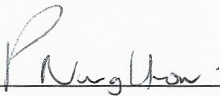Pat Naughton, Sales Director

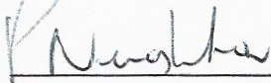

CE The CE marking may only be used if all relevant and effective

CE EC Directives are complied with.

Company Seal ....

**TEMPERATURE SETTINGS AND FOOD WASTE IMPACT**

**Ref: 2019/2024 – Annex II Point 3(b)**

For Optimal food preservation and minimal food waste, this appliance should beset according to the following compartment guidelines.

**Food Category: Temperature: Maximum temperature:**

Salads 2◦c to 4◦c 6◦c

Raw Meat & Poultry 0◦c to 2◦c 4◦c

Dairy Products 2◦c to 4◦c 5◦c

Cooked/Prepared 2◦c to 4◦c 5◦c

Foods

**Important:** consistently maintaining temperatures above these thresholds can significantly shorten produce shelf life and increase food waste.

**Example Temp Deviation Shelf-Life Reduction Food Waste Increase**

Salad +3◦c (from 4◦c to 7◦c) -2 to -3 days 15% - 25% per kg/week

Raw meat +2◦c (from 2◦c to 4◦c) -1 to 1.5 days 10% - 15% per kg/week

Dairy products +2◦c (from 4◦c to 6◦c) -2 days 10% - 20% per kg/week

Cooked foods +2◦c (from 4◦c to 6◦c) -1.5 days 10% - 18% per kg/week

**Tips:**

1. Check internal temperatures regularly using a calibrated thermometer.
2. Store food in correct zones e.g. raw meat in the coolest section.
3. Do not overload shelves/compartments, allow cold air to circulate.
4. Ensure door seals are clean and replaced regularly.
5. Follow FIFO (first in, first out) stock rotation.