Operating Instructions
REFRIGERATOR
&
CHEST FREEZER
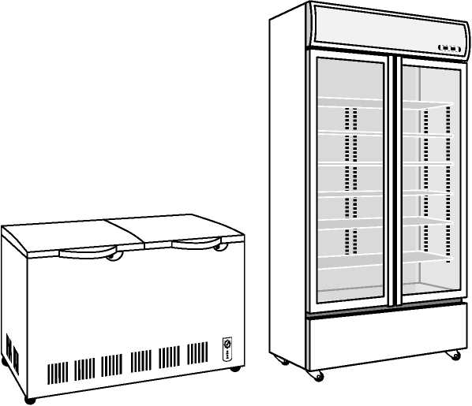

Dear Users,
Thank you so much for choosing our Unifrost Refrigeration.
In order to achieve the highest performance of your products, we highly recommend that you read the User's Manual carefully before using the products, which will provide you with a variety of helpful direction and advice .
Please keep this User's Manual in a safe place for future use.

Please note:
This operating instruction manual is for all the refrigerators and chest freezers.

Contents
Safety Instructions 03
Installation 06
Installation Directions 06
Choosing the right location 06
Installing the water drip 07
Maintenance 08
Operation 08
Structure Diagram °8
For saving energy 09
Use Directions and Cautions 09
Power 09
Setting the temperature 10
Appendix n
When moving or transporting the refrigerator 11
Cleaning and Maintenance 11
Cleaning the whole refrigerator 12
Interior of refrigerator 12
Exterior of refrigerator 12
Control panel 12
Checks after cleaning and maintenance 12
When the refrigerator is not going to be used for a prolonged period 12
Ih>ubleshooting 13
Caring for the environment 15

Safety Instructions
1・ This appliance is intended to be used in the following or similar applications: —staff kitchen areas in shops, offices and other working environments;
--farm houses and by clients in hotels, motels and other residential type environments;
—breakfast type environments;
—catering and similar non-retail applications.
- This appliance can be used by an adult and persons with reduced physical, sensory or mental capabilities or lack of experience and knowledge if they have been given supervision or instruction concerning use of the appliance in a safe way and understand the hazards involved. Children shall not play with the appliance. Cleaning and user maintenance shall not be made by children without supervision.
A
warning Indicates risk of death or serious injury
- Ensure that the refrigerator is plugged into an earthed mains socket and making sure the connection is secure.
• A loosely connected power plug can cause fire or electric shock
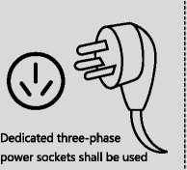
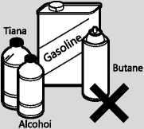
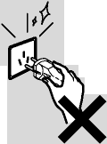
%
When any Flammable gas leaks,do not put or pull the power plug in or out of the socket
- Do not use a multiple socket adaptor and plug several appliances into the same socket adaptor.
- This can cause overheating, fire or short circuit.
- Do not spray inflammable gas near the refrigerator.
- This can cause explosion or fire as the refrigerant (R600A/Ri 34A/R404R/ R290) used in the refrigerator and the gases in the insulation material (cyclopentane) are both flammable.
- Do not spray water onto or into the refrigerator.
- This can cause fire or electric shock.
- Do not operate the refrigerator in the presence of explosive fumes or flammable gas.
- This can cause explosion or fire.
- Do not store volatile or flammable substances in the refrigerator, or use them near the appliance. This can cause explosion or fire.
- Flammable substances such as petrol benzene, thinners, alcohol, ether and Liquid Petroleum Gas (LPG) can cause explosions.
- The refrigerant (R600A/R134A/R404R/R290) used in the refrigerator and the gases in the insulation material (cyclopentane) are both flammable.
- Make sure the supply cord and plug are not squashed or damaged or put any heavy objects on it.
- A damaged power plug or cord can cause short-circuit, fire or electric shock.
- If the supply cord is damaged, it must be replaced by the manufacturer, its service agent or similarly qualified persons in order to avoid a hazard.
- Do not unplug the refrigerator by pulling on the supply cord.
- This can damage to the supply cord. Always grip the plug and pull firmly from the socket
- Do not place any water container on the top of the refrigerator.
- Water can damage insulation of electrical components and cause short circuit, fire or electric shock.
- Do not touch the power plug with wet hands.
- This can cause electric shock.
- Do not install the refrigerator in a damp place, or where it may come into contact with water.
- Deteriorated insulation of electrical parts can cause short circuit, electric shock or fire.
- Do not store pharmaceuticals or other temperature-sensitive products in the refrigerator.
- You should not store products that require strict temperature controls in the refrigerator.
- Do not let children climb, swing or hang on the refrigerator door.
- This can cause serious injury as well as damaging the refrigerator.
- Do not use mechanical devices or other means to accelerate the defrosting process, other than those recommended by the manufacturer.
- This can cause damage to the interior of the refrigerator or cause an
explosion.
- Do not damage the refrigerant circuit.
- Remove any dirt or dust from the plugs pins before connecting to the power supply. Dust build-up on the plug can cause insulation failure, especially in humid conditions. This can cause short circuit, fire or electric shock Unplug the supply cord and wipe it with a dry cloth. Never use a wet or damp cloth.
- Unplug the refrigerator before cleaning and servicing.
• Failure to do this can cause electric shock
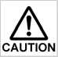
Do not try to disassemble, repair or modify the refrigerator yourself.
• You may injure yourself - or others - with burns or electric shock or damage the refrigerator. If your appliance needs alterations or repair, please consult a relevant service center.
Very Important!!
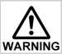
If you smell burning or see smoke coming from the refrigerator disconnect the power immediately and please consult authorized service centre.
Indicates risk of injury or damage to property
- Do not put glass bottles or containers in the freezer.
- When the contents freeze, the glass may break
- Do not touch the inside walls of the freezer or items stored in the freezer with wet hands.
- Your skin can become frozen onto the interior wall, or items stored in the freezer.
- Do not open or close the doors by taking hold of the door handles with both hands.
- This may cause personal injury.
If there's a power cut, avoid opening the refrigerator frequently or putting unchilled food in it as this can cause the temperature inside to rise and spoil food stored inside.
If you're not going to use the refrigerator for a long time, unplug it from the mains.

Installation Directions
Choosing the right location
- Install the refrigerator in a location which satisfies the following criteria:
- Where the refrigerator will not be exposed to direct sunlight
- Where the refrigerator will be at a distance from heating appliances, cooking appliances and other sources of heat
- A location which is well-ventilated and dry
The more refrigerant there is in an appliance, the larger the room it should be installed in. If there is a refrigerant fluid leak, and the appliance is in a small room, the build up of combustible gases is more likely This can cause fire or explosion.
- Where the floor is sturdy and level
- Place the refrigerators on solid and firm ground, and make them stand firmly with blocks.
- Provide clearance to allow heat to dissipate.
- Residual heat is always being emitted from the refrigerator while it is operating.
- Provide sufficient clearance around the refrigerator to allow this heat to dissipate so that its cooling ability is not impaired. There shall be a clearance of no less than 200mm on both sides.
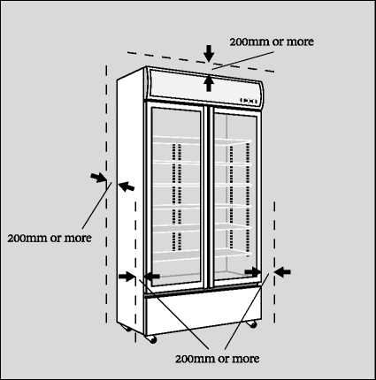

- Unplug the refrigerator before moving. And the refrigerators shall be moved through the wheels at the bottom. In the event that they have to be moved frequently or for a long distance, a cart or a dedicated bottom frame with wheels shall be used.

Installing the water drip
- We put the black tray inside the cabinet during the packing process.
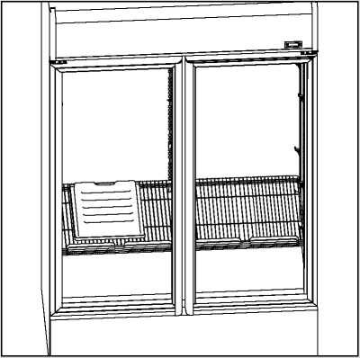

- Please install it by following the instruction: a.There is a support bracket under the compressor; b.Then put the tray on the bracket.
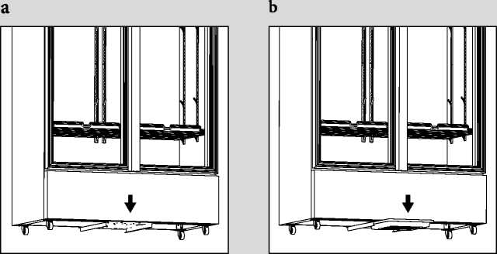
Preparation
Maintenance
Remove all the packing materials and tapes. Wipe the inside of the refrigerator using a soft cloth which has been dipped in lukewarm water and then wrung out.
Connecting the power plug to the power outlet (please do follow the safety instructions)
It takes about 90 minutes to reach the set temperatures (when the room temperature is around 32 °C, there is no food inside the refrigerator, and the doors are closed). Place the food inside the refrigerator only after it reaches certain temperature.
Notes:
• Cooling may take longer in the summer season or when the room temperature is higher.
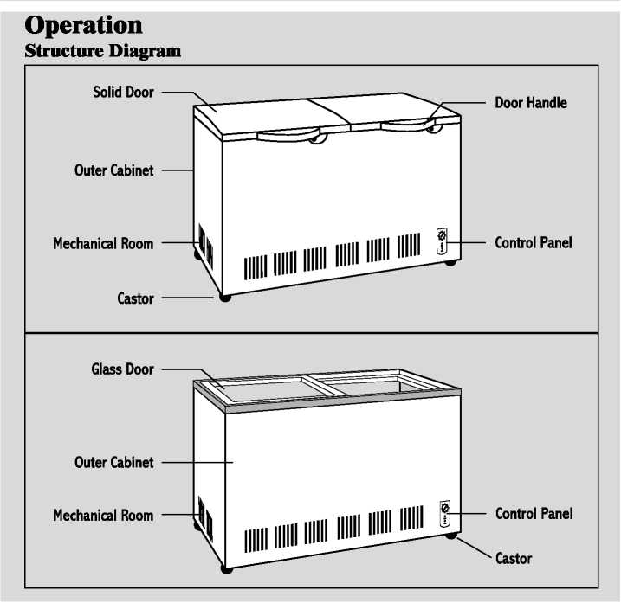
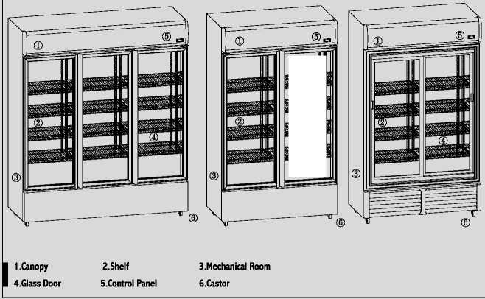
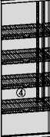

For saving energy
- Install the refrigerator in a dry, cool and well-ventilated location. The colder the ambient temperature, the better the efficiency (Please refer to Page 6, Choosing the right location) Do not overfill the refrigerator to allow the air to circulate.
- Open the doors only when necessary and as briefly as possible.
- Occasionally and gently clean the ventilation openings at the bottom/top of the
- refrigerator with a vacuum cleaner, etc. (Take care not to damage the water pipe or refrigerant pipe inside the cover)
Do not put hot food into the refrigerators, or the temperature will rise to increase power consumption.

Use Directions and Cautions
Power
- After the refrigerator is plugged into an earthed mains socket (please do follow the safety instructions,), please wait for 2-3 hours to store the food into the refrigerator.
- If you need to unplug the refrigerator; wait at least 10 minutes before you plug it back in again. Otherwise you might damage the compressor
- In the event that the voltage is above or below 10 percent rating voltage , please use voltage regulator with a capacity of 1000W or above, or the compressor may be damaged.
- When storing foods inside refrigerator, user shall handle with care. Please do not use any sharp items to scratch or damage the interior panel
- Do not put heavy items on top of the glass or solid door.
Setting the temperature For manual thermostat The Storage temperature is adjustable by setting the thermostat at the bottom or above of refrigerators. Please set the thermostat according to your needs.
For manual thermostat
- The thermostat has "o-7"position (the number does not represent a specific temperature), the larger the number is,the lower the temperature is. Please set the position of knob according to your needs.
- The thermostat is often set at "3-4‘：When it is set at "7： the compressor will run continuously to increase power consumption and decrease the service life of compressor.
- BD series freezers,for "o~7： the larger the number is, the lower the temperature is. For Ware cooling temperature, fbr ‘3〜7^{s}' are freezing temperature. Please set the position of knob according to your needs.
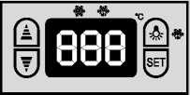
- The inside temperature of the refrigerators base on how much food you put into and ambient temperature. If (you feel) the inside temperature is high% you can turn 0.5~1 position of knob clockwise. If (you feel) the inside temperature is lower; you can turn 0.5-1 position of knob counterclockwise. Please set the position of knob according to your needs.
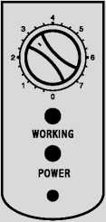
Do not over fill the refrigerator.
- It takes about 90 minutes to reach the set temperatures (when the room temperature is around 32 °C, there is no food inside the refrigerator and the doors are closed) .the process may take longer when the room temperature is higher.

Appendix
When moving or transporting the refrigerator
Before moving or transporting the refrigerator
Shelves
- please take all the shelves and k-dips out when you have to transport or move the refrigerators, otherwise the shelves may fall down and break the glass door during the transportation.
Plug
Do not unplug the refrigerator by pulling on the supply cord.
- This can damage to the supply cord. Always grip the plug and pull firmly from the socket.
The refrigerator must be transported by at least four persons.
- Each person takes hold of the refrigerator at one of its four corners.
. Do not take hold of the doors.
- Tape the doors completely shut so that they will not open.

Cleaning and Maintenance
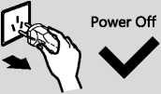
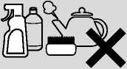

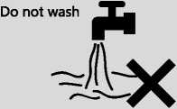
No alkaline washing agent, thineral,,brush,etc.

Before cleaning or conducting maintenance, be absolutely sure to disconnect the power plug from the power outlet. Do not connect or disconnect the power plug with wet hands. Doing so may result in an electric shock or injury;
Cleaning the whole refrigerator
Wipe off easily removable dirt using a cloth dipped in lukewarm water.
Wipe off stubborn dirt using a cloth dipped in some diluted neutral detergent used in the kitchen. Then take up the remaining detergent using a cloth dipped in lukewarm water. To complete the cleaning, be absolutely sure to wipe the surfaces dry to take up the remaining moisture.
Do not use cleaning agents (containing abrasive cleaners, or chemical mixture), and wipe off food stains, seasoning or dirt on the door as soon as possible.
Interior of refrigerator
Interior panel, shelves
Be absolutely sure to wipe off edible oils, butter and other types of fats and oils on the plastic parts. Otherwise, the plastic parts may be damaged. If the shelves are very dirty or smelly remove and wash them.
A dirty or damaged seal will allow the cold air inside to escape. As soon as the seal becomes dirty wipe off the dirt immediately Or you can call the service centre to replace it.
Exterior of refrigerator
If the exterior becomes wipe off the dirt. Also, allowing dust to accumulate on the power plug can cause a fire. At periodic intervals, remove the dust using a drycloth, etc.
Control panel
Wipe these panels using a soft cloth which has been dipped in lukewarm water an then wrung out
As such, take care not to damage their surfaces.
Checks after cleaning and maintenance
Is the supply cord damaged?
Has the power plug become hot?
Is the power plug firmly connected to the power outlet?
If the supply cord is damaged, remove the power plug from the socket and contact your dealer or an authorized service centre.
If LED or LED cover is damaged or if anything appears questionable, contact your dealer or an authorized service centre. Do not attempt to repair, replace or disassemble any damaged parts, etc. yourself
When the refrigerator is not going to be used for a prolonged period
At times like this, disconnect the power plug. Leave the refrigerator doors ajar for two or three days to dry out the interior and prevent odours and mold.

Troubleshooting
Any of the following circumstance is not failure:
- The refrigerating duration is long when a refrigerator is just started up, because the temperature inside the refrigerator is high.
- The temperature on the compressor is high when it runs, and do not touch it with hand.
- The light sound like running water is actually made by the running refrigerant.
If you feel that the refrigerator is not working properly check out the following points first If the trouble persists, disconnect the power plug and contact your service center.
Problem | Cause
The fridge is not chilling (and the freezer is not freezing). | Is the power to the refrigerator on? Poor contact of power plug? Fuse protector broken, abnormal voltage.
The fridge is not chilling (and the freezer is not freezing) satisfactorily. | Is the set temperature too high?  Is the refrigerator exposed to direct sunlight or positioned near a heating appliance?  Have sufficient clearances been provided around the refrigerator? Have the food items been packed too tightly together or is the room temperature high?  Have the doors been opened and closed frequently?  Are the doors completely shut?  When warm food is put inside the refrigerator, the temperature will rise temporarily.  During the cold season or when the room temperature is low, it may feel as if the refrigerator is not chilling.
Too much noise | Has the refrigerator been installed on a sturdy and level floor? Have sufficient clearances been provided around the refrigerator? Is anything vibrating on the top of the refrigerator?  It's normal to hear some noises when the refrigerator starts or stop operation.

The compressor has been running for a long time. | When the power plug has been connected for the first time, the compressor runs longer than usual in order to cool down the inside of the refrigerator until the set temperatures are reached. Have the doors been opened and closed frequently? Are the doors completely shut?  Have the food items been packed too tightly together or is the room temperature high?  When many food items are placed at a time, the compressor will need to run for a longer.
You hear unusual sounds from the refrigerator. | Has the refrigerator been installed on a sturdy and level floor? Have sufficient clearances been provided around the refrigerator? Is anything vibrating on the top of the refrigerator? It's normal to hear some noises when the refrigerator starts or stops operation.
You hear a sound after the compressor has shut down. | This is normal, and is often caused by refrigerant flowing back to the compressor.
You hear a sound after you have opened or closed the door. | This is normal, and is due to the difference in air pressure between the inside and outside of the refrigerator.
You hear the sound of air or water flowing after you have opened the door. | This is caused by refrigerant flowing the internal pipework.
You hear a continuous whining sound. | This sound is heard while the fan for circulating the cold air is operating.  Has the food been packed too tightly together or is the room temperature high?  In cases like these, the fan for circulating the cold air runs at high speed so it makes a loud noise.
The compressor is quite loud. | Has the food been packed too tightly together or is the room temperature high?  In cases like these, the compressor runs at high speed so its normal for the compressor to be louder.

The compressor has been running for a long time. | When the power plug has been connected for the first time, the compressor runs longer than usual in order to cool down the inside of the refrigerator until the set temperatures are reached. Have the doors been opened and closed frequently? Are the doors completely shut?  Have the food items been packed too tightly together or is the room temperature high?  When many food items are placed at a time, the compressor will need to run for a longer.
Condensation forms on the outside of the refrigerator. | Condensation may form when the humidity in the room is high and is normal. Wipe it using a dry cloth.
The outside of the refrigerator feels hot to the touch. | Some heat is normal as the refrigerator incorporates a heat-dissipating pipe to prevent condensation.
The controls on the control panel cannot be operated. | Is the power to the refrigerator on? Has the refrigerator been set to the Child Lock?

Caring for the environment
The refrigerant used in the refrigerator and the gases in the insulation material (cyclopentane) are both flammable. They also require special disposal procedures.
• Before you dispose of the appliance, make sure none of the pipes on the back are damaged. Refrigerant or gas leaks can cause fire or explosion.
Disposing of the packaging
Please recycle where possible (e.g. cardboard, plastic bags, adhesive tape and polystyrene) and make sure you dispose of all other packing material safely
Keep the packaging out of the reach of babies and young children, to avoid injury or suffocation.
Before disposing of your old appliance
Please follow either the disposal instructions from the manufacturer of the old appliance, or local disposal regulations for the appliance. Where this is not available, please follow the three step instructions below
- Remove the plug from the socket
- Cut the supply cord o任 and safely dispose of it with the mains plug still attached.
- Until the old appliance is collected, or you take it to a Recycling Centre, make sure it is out of reach of small children.
• Remove all sealing materials from the door and leave all the shelves and drawers in place.
This way children are less likely to climb in and become trapped.

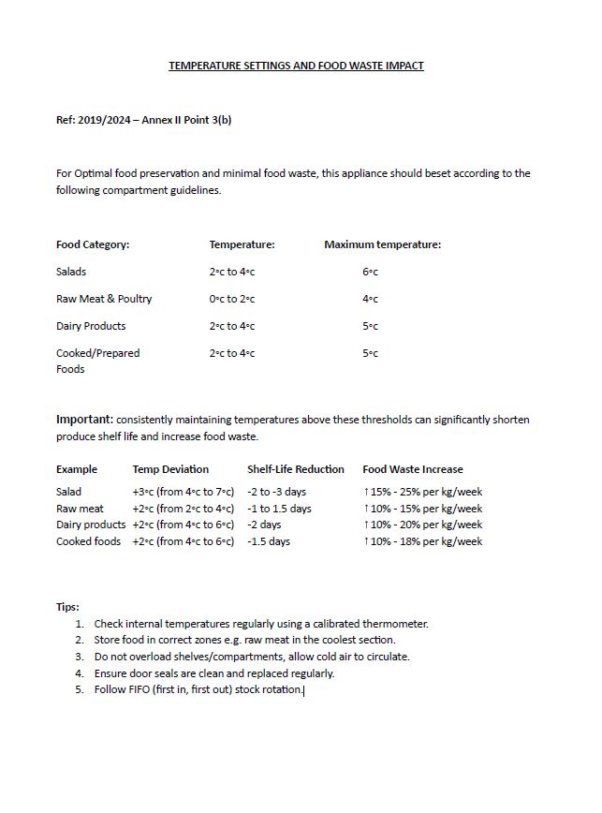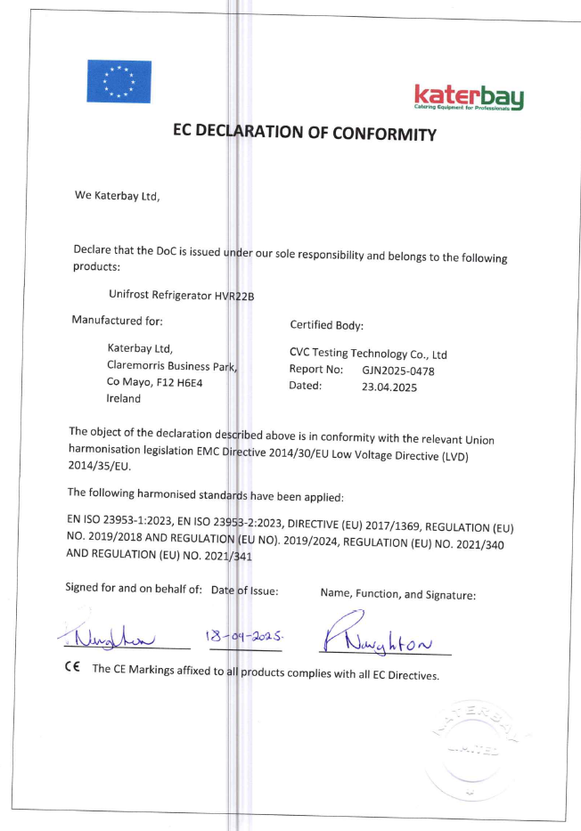

Useful Notes
♦
Please read the Users Manual carefully before using
refrigerator. In order to keep compressor in good
condition, do not start the refrigerator until straight it
up two hours after transportation.
Do not overload cabinet when
using the refrigerator for the first time.
In the environment of high temperature and humidity
there would be condensation
on the glass door.

